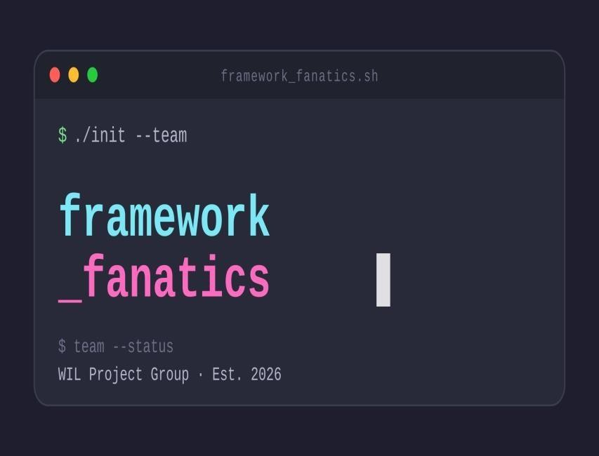

UPDATED SOFTWARE REQUIREMENTS SPECIFICATION – PHASE 1 + PHASE 2 SRS

Cutting Edge Salon Management & Booking System

Module: ITC327W – Work Integrated Learning in Information Technology
Unit: Unit 1: Planning and Requirements Analysis
Date of Submission: 31 August 2026
Lecturer: Mr E Mokoduwe, Mr M Motsoenyane, Ms M Lonergan.
Prepared by:
Name | Student No. | Role
Goitseone  Kgwele | 221050663 | Facilitator / SRS  Coordinator
Thabang Zitha | 223007074 | Note-taker /  Requirements Analyst
Nyakallo Pali | 223060226 | ASP.NET / Backend Lead
Bennet Linda | 224004294 | Flutter / Frontend Lead
Yamkela  Mazamani | 224007421 | Timekeeper /  Documentation

Stakeholder: Cutting Edge Salon (Owner/Management)

Contents
2. Project Title 3
3. Problem Statement 3
4. Purpose, Aim and Objectives 4
4.1 Purpose 4
4.2 Aim 5
4.3 Objectives 5
5. Project Scope 5
6. Deliverables and Acceptance Criteria 7
7. Exclusions, Constraints and Assumptions 8
Exclusions 8
Constraints 8
Assumptions 8
8. Stakeholders and User Groups 9
9. Current Process and Diagram 10
9.1 Current Process Description 10
9.2 Current Process Diagram 11
9.3 Proposed (To-Be) Process Flow 13
1. Customer Flow 13
2. System Logic – Conflict Detection (The Core Improvement) 14
3. Customer Cancellation Flow 14
4. Manager Flow 15
Key Improvements Over the Current Process 15
• How This Addresses the Stakeholder's Needs 16
10. Product Perspective 18
11. Main Flutter, ASP.NET and Supabase Functions 19
12. Functional Requirements 21
13. Non-Functional Requirements 23
14. System Requirements 24
15. Integration Requirements 26
16. Requirements Prioritisation (MoSCoW) 27
17. Appendices Containing Stakeholder Evidence 28
Conduct a Feasibility Study 32
Review Your Current Project 32
Evaluate Technical Feasibility 34
Technical Feasibility Decision 35
Evaluate Operational Feasibility 36
Operational Feasibility Decision 37
Evaluate Economic Feasibility 37
Economic Feasibility Decision 38
Evaluate Schedule Feasibility 38
Schedule Feasibility Decision 39
Evaluate Legal Feasibility 39
Legal Feasibility Decision 40
Evaluate Ethical Feasibility 40
Ethical Feasibility Decision 41
Complete the Feasibility Summary 41
Step 9: Make an Overall Feasibility Decision 42
Prepare a Project Risk Register 43
Identify Project Risks 43
Project Risk Register 43
Review the Highest Risks 49
Update Your Project Records 50
Refine the SRS and Project Plan 50
Review the Feasibility and Risk Findings 50
Step 2: Refine the Project Scope 51
Update the Requirements 53
New Functional Requirements 53
Updated Requirements Change Log 53
Updated Database Schema 54

2. Project Title
Cutting Edge Salon Management & Booking System

3. Problem Statement
Element | Response
Current Situation | Cutting Edge Salon currently uses manual, paper-based diaries and telephone calls to manage daily store operations and appointment bookings.
Problem | This results in mismanagement of daily store operations, including double bookings, missed customer appointments, lost contact details, and difficulty managing stylist availability and service promotions.
Affected Users | The problem affects the salon owner, stylists, and customers.
Consequences | The owner cannot efficiently track daily revenue, staff schedules, or service demand. Stylists experience overlapping bookings. Customers cannot view service prices, availability, or book appointments outside operating hours (Weekdays 9:00-18:00, Saturdays 8:30-17:00, Sundays 08:30 -13:00).
Need | An improved solution is needed to automate the booking process, showcase services and pricing online, reduce administrative errors, and provide a seamless "luxury" experience.
Complete Problem Statement: The organisation currently uses manual, paper-based diaries and telephone calls to complete daily store operations and appointment bookings. This results in mismanagement of daily store running, double-bookings, missed customer appointments, and lost contact details. The problem affects the salon owner, stylists, and customers because appointments cannot be managed efficiently. An improved solution is needed to automate the booking process, showcase services and pricing online, reduce administrative errors, and provide a seamless "luxury" experience.

4. Purpose, Aim and Objectives

4.1 Purpose
The purpose of this project is to develop an integrated, web-based and mobile-friendly management system that replaces the manual paper-based process at Cutting Edge Salon with an automated, centralised digital solution.

4.2 Aim
To streamline Cutting Edge Salon's daily operations, improve customer satisfaction, and increase revenue by providing a seamless online booking and service showcase experience.

4.3 Objectives
- Design and implement an online booking portal that allows customers to view available time slots and stylists, reducing booking errors by eliminating manual double-booking.
- Develop an admin dashboard for the salon manager to monitor appointments, manage stylist schedules, and track daily sales.
- Create a service catalogue displaying all services with accurate pricing and durations (standard haircut = 40 min, Cut & Dye = 1h 15min).
- Enable customers to select their preferred payment method (cash or card) upon booking to allow staff to prepare accordingly upon customer arrival.
- Enable customers to cancel their bookings online before the appointment time, empowering users and reducing administrative burden on staff.
- Integrate automated confirmation notifications via email to reduce no-show rates.
- Ensure a "luxury" user interface that reflects the salon's brand identity, appealing to their target market (ages 10–30).
- Promote the "Cut and Dye" service as the flagship offering.

5. Project Scope
Scope Element | Details
Project Title | Cutting Edge Salon Management & Booking System
Aim | To develop an integrated prototype for managing salon bookings, showcasing services, and promoting the "Cut and Dye" service.
Objectives | Allow customers to book online; select payment method  (cash/card); cancel bookings online; allow staff to manage schedules; promote specific services (Cut & Dye); display gallery of previous hairstyles.
Deliverables | Flutter Android mobile application, ASP.NET Manager Portal/Web Application, shared Supabase backend, GitHub repository, Microsoft Project schedule, SRS document and Excel Progress Tracker.
Acceptance Criteria | A customer must be able to book an appointment end-to-end; select a payment method (cash or card); cancel their booking online; the admin must be able to view and manage all bookings; the system must prevent double bookings; the system must display a "luxury" aesthetic.
Exclusions | WhatsApp Business API (stakeholder confirmed "NO"); full Point-ofSale (POS) hardware integration; advanced accounting/payroll systems; offline mode; online payments in Phase 1.
Constraints | Must be developed using Flutter, ASP.NET Core, and Supabase; project must be completed within the semester; no paid third-party APIs for core functionality.
Assumptions | The stakeholder will provide professional photos and brand colours; the target users (ages 10-30) have basic digital literacy and stable internet access; the stakeholder will be available for feedback and validation.

6. Deliverables and Acceptance Criteria
Deliverable | Acceptance Criteria
Initial SRS  Document | Submitted as one PDF. Contains all required sections. Approved by the lecturer.
Working  Web/Mobile  Application | The system must be accessible via a browser. Customers must be able to book an appointment end-to-end without assistance. Customers must select a payment method and cancel bookings.
Source Code  (GitHub) | All code committed to a shared GitHub repository with a working link provided to the lecturer.
Supabase  Database Setup | Database configured with tables for Users, Bookings, Services, Stylists, Payment Methods, and Cancellation Records. Screenshot included in the SRS appendix.
Admin Dashboard | The manager must be able to view, create, edit, and delete appointments and stylist profiles. Must be able to track payment preferences and process cancellations.
Project Progress  Tracker | Completed Excel workbook with task progress, individual contributions, and stakeholder engagement logs.
Microsoft Project  Schedule | .mpp file showing the timeline from August to project handover.

7. Exclusions, Constraints and Assumptions

Exclusions
- The system will not handle complex retail inventory management for products in this phase (only service booking is prioritised).
- No WhatsApp Business API integration (stakeholder explicitly confirmed "NO" to WhatsApp for bookings).
- No offline mode will be supported.
- Online payments will not be implemented in Phase 1.

Constraints
- Technology Stack: Must be developed using Flutter, ASP.NET, and Supabase.
- Time: Initial SRS due by 25 August 2026.
- Budget: Free tiers of SMTP and Maps APIs will be utilised.

Assumptions
- Salon staff and customers have basic digital literacy and stable internet access.
- The stakeholder will provide professional photos and brand colours.
- Standard haircuts take 40 minutes; Cut & Dye takes 1 hour 15 minutes.
- All stylists offer the same services. • Customers will have access to the internet to book and cancel appointments.
- The salon will have staff available to manage bookings and cancellations through the admin dashboard.

8. Stakeholders and User Groups
Stakeholder/User | Role & Description
Salon Manager  (Owner) | Primary stakeholder. Has full administrative rights to manage stylists, view all bookings, generate reports, and update service information.  Needs to solve mismanagement of daily store running.
Stylist (Service  Provider) | All stylists offer the same services. They need to view their personal daily schedule.
Customer (End-  User) | Target market (ages 10-30, catering to men/women/children). Need to view services, prices, and book appointments online. Expects a "Luxury" feel.  Must be able to select payment method and cancel bookings.
Competitors | Legendary Barber (identified as the main competitor).

9. Current Process and Diagram

9.1 Current Process Description
- Customer Inquiry: Customer calls (0787676599) or walks in to ask about service availability, prices, or booking times.
- Manual Checking: Staff manually check a physical diary to see if the requested date and stylist are free.
| P a g e

- Verbal Booking: If available, staff write the customer's name and contact details into the diary. No digital record exists.
- Service Delivery: Customer arrives at 10 Melck Street, Pioneer Building, Welkom Central. No prenotification system.
- Payment: Handled manually in-store.
- Result: If the customer does not show up, the slot is wasted. No data to analyse peak times.

9.2 Current Process Diagram

Figure 1: Current manual booking process at Cutting Edge Salon

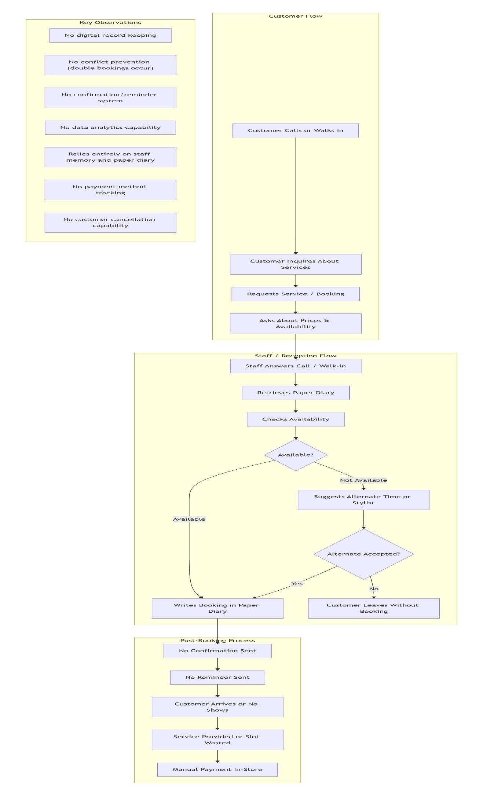

9.3 Proposed (To-Be) Process Flow

The proposed To-Be Process represents the ideal automated workflow for Cutting Edge Salon, designed to eliminate the manual mismanagement identified in the current process. The flowchart is divided into three distinct actors: the Customer, the System, and the Manager.

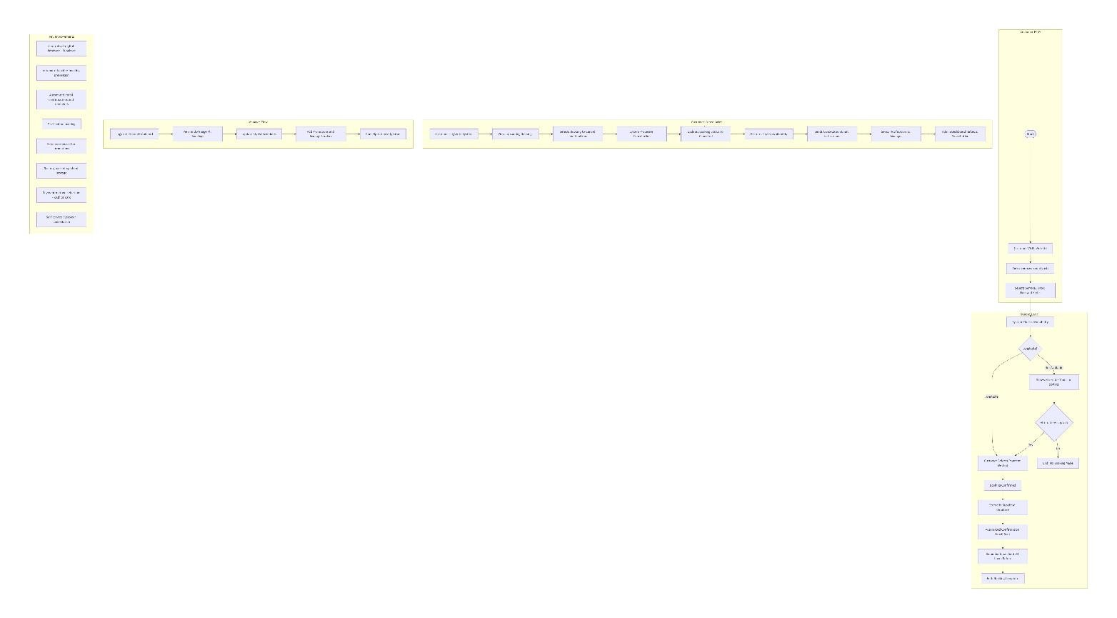

1. Customer Flow
The process begins when a customer visits the Cutting Edge website (built with Flutter). They can:
- View the service catalogue – Hair Cutting, Hair Colouring, Beard Shaving, and Hot Towel Treatment, with clear pricing and durations (Standard haircut = 40 minutes; Cut & Dye = 1 hour 15 minutes, as per interview).
- View stylist profiles – All stylists offer the same services, allowing customers to choose based on preference.
- Select a service, date, and time that suits their schedule, with real-time availability displayed.
- Select their preferred payment method (cash or card) upon booking to allow staff to prepare accordingly upon customer arrival.

2. System Logic – Conflict Detection (The Core Improvement)
Once the customer submits the booking, the system validates the selected stylist/date/time against the shared Supabase booking and availability data to prevent double booking.
If available: The system proceeds to capture the customer's name and contact details. The booking is confirmed and stored in the Supabase SQL database, including payment method preference. An automated confirmation email is sent immediately, followed by a reminder email 24 hours before the appointment to reduce no-shows (a key stakeholder request).
- If not available: The system immediately suggests alternate times or stylists. If the customer accepts an alternate, the flow rejoins the booking path. If they decline, the session ends without a booking.

3. Customer Cancellation Flow

The system provides customers with self-service cancellation capabilities:
- Customer initiates cancellation: Customer logs into the system and views their upcoming bookings.
- Customer selects booking to cancel: Customer selects the booking they wish to cancel and confirms cancellation.
- System processes cancellation: The system validates the cancellation request, updates the booking status to "cancelled," restores the stylist's availability for that time slot, and sends a cancellation confirmation email to the customer and notification to the salon manager.
- Manager is notified: The admin dashboard reflects the cancellation in real-time, and the manager receives a notification.

4. Manager Flow
In parallel, the salon manager uses a secure Admin Dashboard (ASP.NET web application) to maintain the system:
- View and manage all bookings – Monitor daily appointments, approve, cancel, or reschedule as needed. Track customer payment method preferences
- Update stylist schedules – Assign working hours (Weekdays 9:00 – 18:00, Saturdays 8:30 – 17:00, Sundays 08:30-13:00).
- Add promotions – Create monthly specials, holiday offers, and birthday discounts to promote specific services like "Cut and Dye" – the stakeholder's flagship service.
- Process cancellations — View cancelled bookings, track cancellation trends, and manage availability restoration.

Explanation of the Proposed Process Flowchart
The proposed To-Be Process represents the ideal automated workflow for Cutting Edge Salon, designed to eliminate the manual mismanagement identified in the current process. The flowchart is divided into three distinct actors: the Customer, the System, and the Manager.

Key Improvements Over the Current Process
Current (As-Is) – Manual | Proposed (To-Be) – Automated
Paper diary | Centralised digital database (Supabase)
No conflict checking | Automated double-booking prevention
No confirmation/reminders | Automated email confirmations & reminders
No customer self-service | 24/7 online booking with cancellation capabilities
No promotional management | Admin dashboard for promotions
No data backup | Secure, backed-up cloud storage
Current (As-Is) – Manual | Proposed (To-Be) – Automated
No payment preference tracking | Payment method selection (cash/card)

• How This Addresses the Stakeholder's Needs
Stakeholder Request | How the Proposed Process Fulfils It
"To alleviate mismanagement of daily store running" | Centralised digital management eliminates manual errors.
"To allow for a smooth booking system" | 24/7 online booking with conflict detection ensures seamless scheduling.
"Customers must book appointments online" | Customer flow allows easy self-service booking.
"Promote Cut and Dye the most" | Manager can add targeted promotions via the dashboard.
"Luxury feel" | Automated confirmations and reminders enhance the premium customer experience.
"Customer should select payment method" | Customers select cash/card upon booking; staff prepares accordingly.
"Customers must cancel their order" | Self-service cancellation empowers customers and reduces admin burden.
"Prevent double bookings" | Conflict detection system ensures no overlapping appointments.

• This proposed workflow directly addresses the stakeholder's need to "alleviate mismanagement of daily store running" and deliver a "luxury" experience to their customers, as explicitly requested during the interview, while incorporating lecturer-advised enhancements: payment method selection and customer cancellation.

10. Product Perspective
The Cutting Edge Salon Management System is a new, customer + Stylist use one shared Flutter Android application, while Manager uses the ASP.NET web portal intended to replace the current manual diary and spreadsheet system.
- System Interfaces: Integrates with Google Maps (10 Melck Street, Pioneer Building, Welkom Central) and an SMTP/Email service.
- User Interfaces: A responsive, "Luxury" themed UI built with Flutter. Includes Public Frontend
(Home, About Us, Services, Pricing, Our Team, Gallery, Booking, payment method selection, Customer Cancellation) and Secure Admin Backend (Payment Tracking , Cancellation Management ).
- Communication Interfaces: HTTPS protocols for all API calls.

11. Main Flutter, ASP.NET and Supabase Functions
Component | Main Functions
Flutter | FRONTEND: Builds a responsive web and mobile UI for customers. Manages navigation across required pages.  Handles client-side form validation for booking.  Displays payment method selection (cash/card).  Provides a customer cancellation interface. Displays Google Maps integration for salon location. Provides the "Luxury" aesthetic required by the stakeholder.  Displays real-time availability of stylists and time slots. Shows service catalogue with pricing and durations.  BACKEND: Manages local state and caching for improved performance. Handles direct CRUD operations with  Supabase (customers can view services, stylists, and create bookings, select payment methods, cancel bookings). Implements client-side logic for booking flow. Manages local notifications. Validates booking data before submission. Handles error handling and user feedback.  Manages offlinefriendly features where applicable.
ASP.NET Core | FRONTEND: Builds a secure, responsive web-based admin dashboard for the salon manager. Provides an interface for managing all bookings (view, create, edit, delete). Tracks payment method preferences. Manages cancellations and availability restoration. Manages stylist profiles (add, edit, delete) for stylists. Displays daily sales tracking and revenue reports. Allows creation of promotions and service updates to promote "Cut and Dye" as the flagship service. Provides access to customer data and appointment history. Displays operating hours.  BACKEND: Provides secure RESTful API endpoints for the admin dashboard (if needed). Implements JWT authentication for manager access control. Contains core administrative business logic (manager-level conflict detection, booking management, cancellation processing, payment tracking). Handles data sanitization and validation for all admin operations. Manages email automation (confirmation, cancellation, and reminder emails 24 hours before appointments) via SMTP integration. Generates sales reports and analytics for the manager. Enforces rolebased access
 | control (only managers can access admin features). Manages secure data operations with Supabase.
Supabase (Database/Auth/Storage) | SQL database stores Users, Stylists, Services,  Bookings, Payment Methods, Cancellation Records. Built-in Authentication (Row Level Security). Real time subscriptions. Stores uploaded images.

12. Functional Requirements
ID | Requirement | Priority
FR01 | The customer must be able to view the service catalogue with prices and durations. | Must
FR02 | The customer must be able to view available stylist profiles | Must
FR03 | The customer must be able to book an appointment by selecting a Stylist, Date, and Time. | Must
FR04 | The system must prevent double bookings (conflict detection for the same stylist at the same time). | Must
FR05 | The system must send a confirmation email after a booking is created. | Must
FR06 | The manager must be able to view, modify, or cancel any booking through the admin dashboard. | Must
FR07 | The manager must be able to add, edit, and delete stylist profiles. | Must
FR08 | The customer must be able to cancel their booking online before the appointment time. | Must
FR09 | The system should send automated appointment reminders (e.g., 24 hours before). | Should
FR10 | The system must display the physical address (10 Melck Street, Pioneer Building, Welkom Central), contact number (0787676599), and email (cutinged@88@gmail.com). | Must
FR11 | The system must include Google Maps integration to show the salon location. | Must
FR12 | The system must include functional links to social media (Instagram, Facebook, TikTok). | Must
FR13 | The system must allow customers to view a gallery of previous hairstyles and salon work. | Should
FR14 | The system must include the following pages: Home, About Us, Services, Pricing, Our Team, Gallery, Booking. | Must
FR15 | The system must promote the "Cut and Dye" service as the flagship offering. | Must
FR16 | The system must display operating hours: Weekdays 9:00-18:00, Saturdays 8:3017:00, Sunday 8:30-13:00. | Must
FR17 | The system must display parking information: "Free parking available." | Should
FR18 | The customer must be able to select their payment method (cash or card) when booking an appointment. | Must

13. Non-Functional Requirements
ID | Requirement
NFR-  01 | The UI must reflect a "Luxury" feel and be easy to navigate for users aged 10-30.
NFR-  02 | Page load time must not exceed 3 seconds on a standard broadband connection.
NFR-  03 | User passwords must be hashed and stored securely via Supabase Auth. Session tokens must expire.
NFR-  04 | The system must be available 99% of the time.
NFR-  05 | ASP.NET code must follow clean architecture principles and contain clear comments.
NFR-  06 | Only authorised staff (managers) must be able to access the administration dashboard.
NFR-  07 | Error messages must be clear, understandable, and user-friendly.
NFR-  08 | The prototype must use test data instead of real customer information during development.

14. System Requirements
ID | Requirement
SR01 | The mobile/web frontend must be developed using Flutter.
SR02 | The backend API must be developed using ASP.NET Core.
SR03 | The shared database and authentication must use Supabase (PostgreSQL).
SR04 | The source code must be stored in a GitHub repository.
SR05 | The application must be accessible via modern browsers (Chrome, Firefox, Safari) on desktop, tablet, and mobile.
SR06 | The system must use test data during development and staging phases.

15. Integration Requirements
ID | Requirement
IR-  01 | Information entered through Flutter must be stored in Supabase.
IR-  02 | Records stored in Supabase must be available to the ASP.NET application.
IR-  03 | Updates made through ASP.NET must be reflected in Flutter where applicable (real-time booking updates).
IR-  04 | The system must integrate with Google Maps API to display the location of 10 Melck Street, Pioneer Building, Welkom Central.
IR-  05 | The system must integrate with an SMTP/Email service (e.g., SendGrid or Gmail SMTP) to send confirmation, cancellation, and reminder emails.
IR-  06 | The system must integrate social media links (Instagram, Facebook, TikTok) on the website.

16. Requirements Prioritisation (MoSCoW)
Priority | Requirements
Must  Have (Essential) | Core Booking (FR-03), Conflict Prevention (FR-04), Admin Dashboard (FR-  06), Service Catalogue (FR-01), Google Maps (FR-11), Display Contact  Info (FR-10), Required Pages (FR-14), Promote "Cut and Dye" (FR-15),  Display Hours (FR-16), Customer Cancellation (FR-08), Payment Method Selection (FR-18)
Should  Have (Important) | Email Reminders (FR-09), Customer Self-Cancellation (FR-08), Gallery (FR-13), Social Media Links (FR-12), Parking Info (FR-17).
Could Have (If Time  Permits) | Online Product Purchases, Advanced Sales Analytics, Customer Reviews.
Won't Have (This  Phase) | WhatsApp API Integration (stakeholder confirmed "NO"), Online Payments, POS Integration.

17. Appendices Containing Stakeholder Evidence
Appendix A: Interview Questions and Responses (Full Transcript)
(If the images are not visible, please refer to the evidence folder)
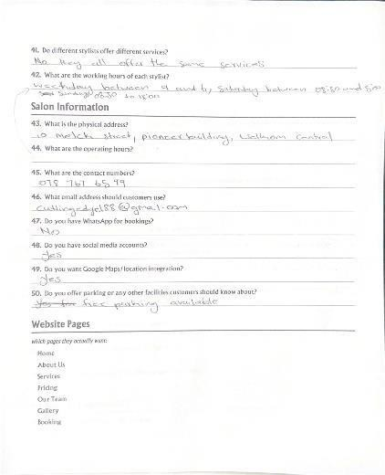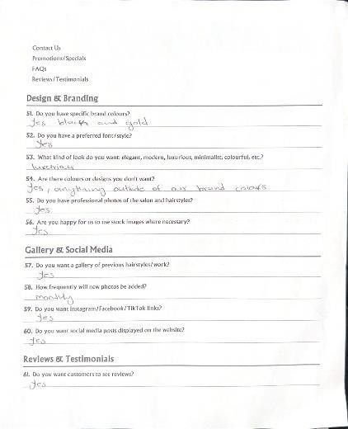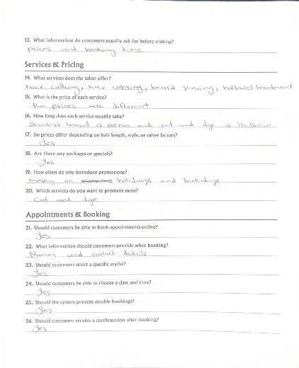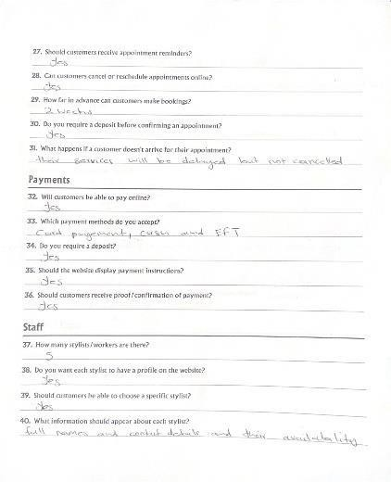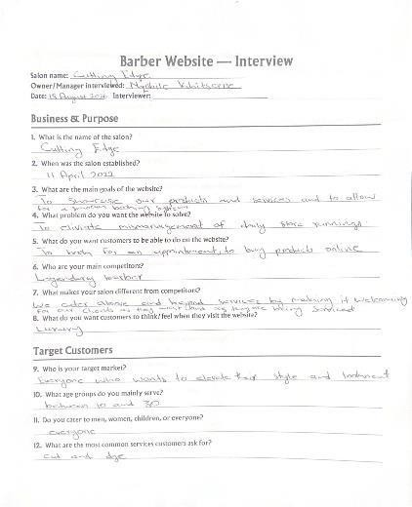

- Salon Name: Cutting Edge
- Established: 11 April 2022
- Main Problem: "To alleviate mismanagement of daily store running."
- Main Goals: "To showcase our products and services and to allow for a smooth booking system."
- Target Audience: 10 – 30 years old, everyone (Men, Women, Children).
- Core Services: Hair cutting, hair colouring, beard shaving, hot towel treatment.
- Brand Vibe: "Luxury."
- Competitor: Legendary Barber.
- Desired Pages: Home, About Us, Services, Pricing, Our Team, Gallery, Booking.
- Operating Hours: Weekdays 9-6, Saturdays 8:30-5.
- Address: 10 Melck street, pioneer building, Welkom Central.
- Contact: 0787676599 / cutinged@88@gmail.com
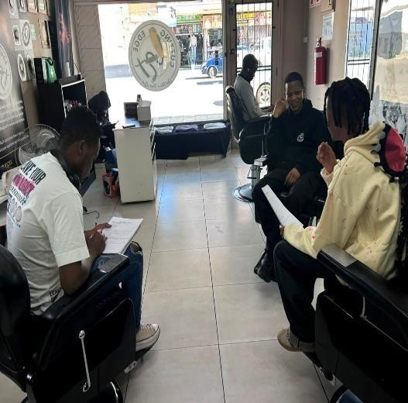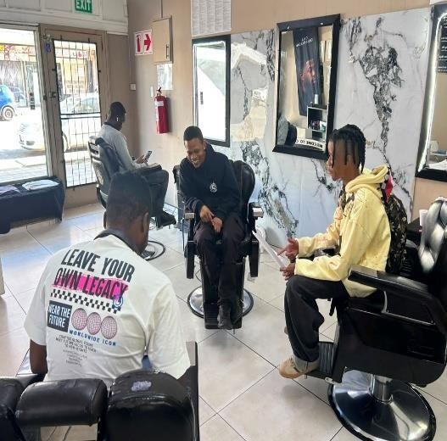
•

Stylists:

All offer the same services.

Caption: Interview conducted with Cutting Edge Salon owner/manager on 18 August 2026.
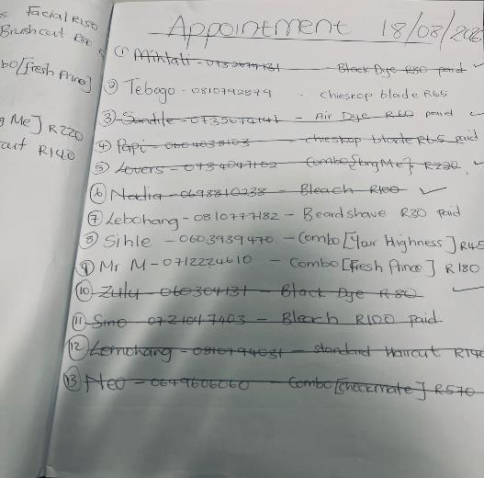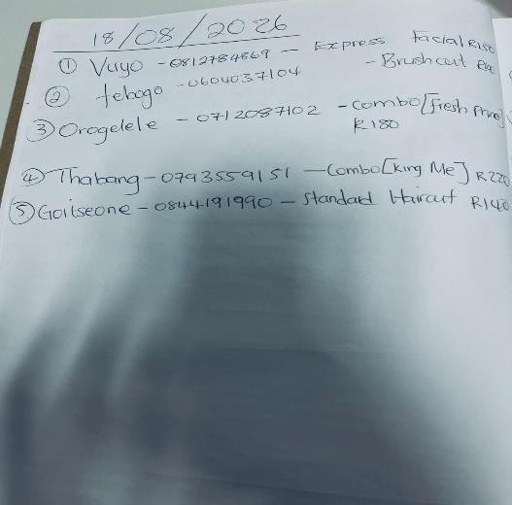

Caption: Discussion of current booking process and manual diary.



Caption: Front view of Cutting Edge Salon at 10 Melck Street, Welkom.
Appendix C: Stakeholder Confirmation of Findings
We summarised the main findings at the end of the interview and asked the stakeholder to confirm that our understanding was correct.
Summary Confirmed:
- The current manual diary system is inefficient and causes mismanagement.
- The stakeholder wants customers to book online.
- The stakeholder wants a "Luxury" feel.
- The stakeholder does NOT want WhatsApp bookings.
- The stakeholder has stylists who all offer the same services.
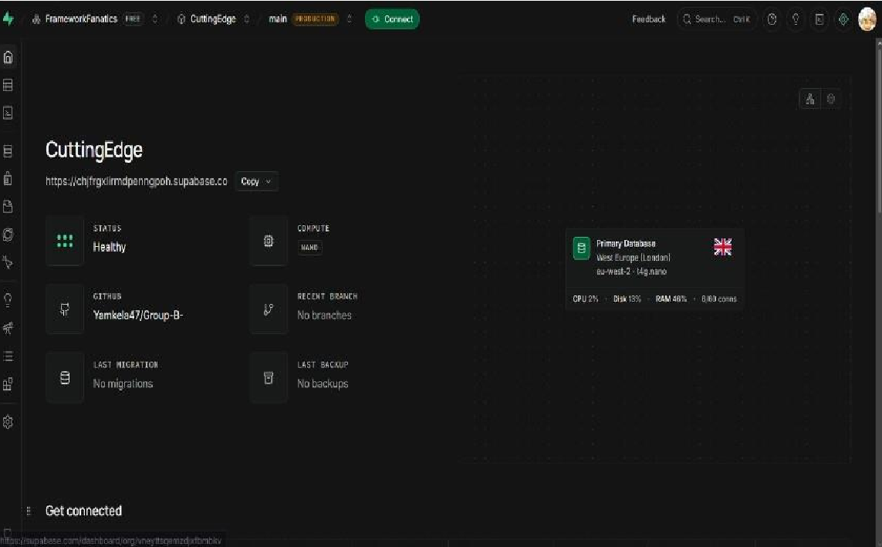
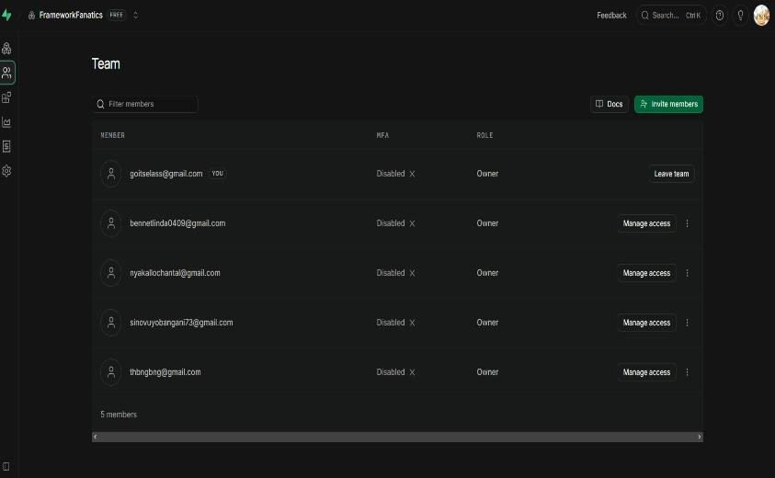
- The stakeholder wants pages: Home, About Us, Services, Pricing, Our Team, Gallery, Booking. Link to github https://github.com/Yamkela47/Group-B-.git

Caption: Supabase project created for "Cutting Edge SMS".


Appendix E: Stakeholder Brand Colours and Fonts

Caption: Brand identity material provided by Cutting Edge Salon stakeholder.

UNIT 2
Feasibility and Risk Analysis
Cutting Edge Salon Management & Booking System

Conduct a Feasibility Study

Review Your Current Project
Question | Group Response
What is the main problem being addressed? | Cutting Edge Salon currently uses manual, paper-based diaries and telephone calls to manage daily store operations and appointment bookings. This results in double bookings, missed customer appointments, lost contact details, and difficulty managing stylist availability and service promotions.

What are the main Flutter functions? | - Service catalogue display with pricing and durations  - Stylist profiles viewing  - Online booking with date/time selection • Payment method selection (cash or card) upon arrival  - Customer cancellation functionality  - Google Maps integration  - Gallery viewing  - Luxury UI with brand identity  - Contact information display  - Social media links
What are the main ASP.NET functions? | - Admin dashboard for booking management  - Stylist profile management (CRUD)  - Conflict detection logic for doublebooking prevention  - Booking cancellation processing  - Payment method tracking  - JWT authentication  - Email confirmation sending  - Promotions management  - Report generation
What information will Supabase manage? | - Users (managers, stylists, customers)  - Bookings (customer name, contact  details, stylist, service, date, time, status, payment method, cancellation status)  - Services (name, description, duration, price)  - Stylists (name, photo, availability)
- Promotions (title, description, dates)
- Gallery images
Which functions appear most difficult? | - Real-time conflict detection logic  - Supabase integration with ASP.NET  - Email notification integration  - Customer cancellation processing and availability updates  - Google Maps API integration • Admin dashboard with full CRUD operations • Professional luxury UI design
Which functions require skills the group still needs to develop? | All group members have practical experience in Flutter, ASP.NET, and Supabase from previous coursework. The group consists of Three members who are particularly strong with coding and 2 members who are skilled in documentation, UML diagrams, and code design. To further enhance our skills and stay current with industry practices, four group members have enrolled in the GenAI course conducted by Ms Lonergan, which covers advanced topics including Supabase integration with ASP.NET. The knowledge gained will be shared across the entire group to ensure all members benefit.
Which functions may require more time than is available? | - Gallery management system  - Promotions management dashboard  - Advanced reporting functionality

Evaluate Technical Feasibility
Question | Group Finding
Does the group have the required Flutter skills? | Yes - All group members have practical experience from previous coursework. 3 members are particularly strong with coding and have practical Flutter experience. The other 2 members, skilled in design and documentation, also have practical experience with Flutter concepts.
Does the group have the required ASP.NET skills? | Yes - All group members have practical experience from previous coursework. 3 members are particularly strong with coding and have practical ASP.NET experience. The group is well equipped to build the backend API.
Can the group work with Supabase? | Yes - All group members have practical experience with Supabase from previous coursework. To further strengthen our skills and stay current with best practices, four group members have enrolled in the GenAI
 | course conducted by Ms Lonergan, which provides advanced training on Supabase integration with ASP.NET. The enrolled members will share learnings with the entire group.
Can Flutter and ASP.NET connect to the same Supabase backend? | Yes - Both can connect to Supabase via REST  APIs and PostgreSQL connections. The group has the necessary practical experience to implement this integration effectively.
Are suitable development computers available? | Yes - All group members have personal computers capable of running Visual Studio, VS Code, Flutter SDK, and .NET Core
Are suitable test devices available? | Yes - Group members have various devices including Android phones, iPhones, and laptops for testing web/mobile responsiveness
Is reliable internet access available? | Yes - All group members have access to stable internet connections for development and research
Which technical skills are being enhanced? | - Supabase integration with ASP.NET  - JWT authentication implementation • Supabase RLS policies (being enhanced through the GenAI course)  - Integration testing between Flutter and  ASP.NET  - Email service configuration  (SMTP/SendGrid)  - Payment method tracking logic  - Cancellation workflow implementation
Which functions may require careful implementation? | - Advanced conflict detection with real time updates  - Comprehensive reporting dashboard •  Professional grade email notification system • Cancellation logic and availability restoration  - Payment method selection and tracking

Technical Feasibility Decision
Feasible with changes
The project is technically feasible with changes. All group members have practical experience in Flutter, ASP.NET, and Supabase from previous coursework, providing a strong baseline for development. The group includes Three members who are particularly strong with coding and are proficient with ASP.NET, Flutter, and backend logic, ensuring that technical implementation can proceed effectively. Additionally, 2 members are skilled in documentation, UML diagrams, and code design, contributing to high-quality documentation and system architecture.
The additional requirements from the lecturer:
Payment method selection (cash or card) and customer cancellation functionality are technically achievable. Payment method selection is a straightforward data capture enhancement that requires minimal additional development effort. Customer cancellation functionality requires careful implementation of workflow logic, including availability restoration and notification triggers. Both features are within the group's technical capabilities and can be implemented within the semester timeframe.
To further strengthen our technical capabilities and stay current with best practices, four group members have enrolled in the GenAI course conducted by Ms Lonergan, which covers advanced topics including Supabase integration with ASP.NET. The knowledge gained will be shared across the entire group. This demonstrates the group's commitment to professional development and delivering highquality work.
The functions are achievable within the semester with proper planning, prioritisation, and leveraging the group's strong coding foundation.

Evaluate Operational Feasibility
Question | Group Finding
Will the prototype address the stakeholder's problem? | Yes - The system addresses the core problem of manual diary mismanagement by providing automated booking, conflict detection, centralized digital records, payment method tracking, and customer cancellation capabilities
Who will use the mobile application? | Customers will use the Flutter web/mobile application to view services, book appointments, select payment  methods, cancel bookings, and access salon information
Who will use the web application? | Salon manager/owner and stylists will use the ASP.NET web application to manage bookings, view schedules, track payment methods, and update information
Do the intended users have suitable devices? | Yes - Target users typically have smartphones with internet access. The manager has a computer for admin tasks
Do users have suitable internet access? | Yes - Customers will access the system primarily via mobile data or Wi-Fi. The salon has internet connectivity for staff use
Will the proposed solution fit the organization’s current activities? | Yes - The system integrates with existing salon operations by digitizing the booking process while maintaining the same service structure. Payment method tracking helps staff prepare for customer arrivals, and customer cancellation reduces staff workload
Will users require guidance or training? | Yes - Staff will need training in using the admin dashboard, and tracking payment
preferences. Customers will need minimal
guidance as the interface will be intuitive
Are any proposed functions unsuitable for the intended users? | The gallery management and promotions dashboard may be too complex for the manager initially; these may need simplification. Cancellation  functionality should be straightforward and userfriendly

Operational Feasibility Decision
Feasible with changes
The project is operationally feasible with changes. The proposed system directly addresses the stakeholder's need for improved booking management and provides a "luxury" customer experience. Payment method selection enhances the customer experience by allowing staff to prepare for payment preferences before customer arrival. Customer cancellation functionality reduces administrative burden on staff and improves customer satisfaction by providing self-service options. The users are digitally literate and comfortable with mobile applications. Staff will require training on the admin dashboard. The group will provide clear user documentation and conduct training sessions for the salon manager.

Evaluate Economic Feasibility
Resource | Available? | Action Required
Internet access or data | Yes | No action required - all members have internet access
Transport to the stakeholder | Yes | Public transport available to Welkom Central; group can coordinate visits
Development computers | Yes | All members have suitable development computers
Test devices | Yes | Group members have Android phones, iPhones, and laptops  for testing
Required software | Yes | Visual Studio Community  (free), VS Code (free), Flutter  SDK (free), .NET Core (free)
Supabase resources | Yes | Supabase free tier provides adequate resources for prototype development
Presentation resources | Yes | Microsoft PowerPoint, Google  Slides, or Canva available
Other project resources | Yes | GitHub free tier, email services  (SMTP free tier), Google Maps  API free tier

Economic Feasibility Decision
Feasible
The project is economically feasible. All required resources are available at no cost through free tiers of the necessary services. The group has access to development computers, test devices, and internet connectivity. Supabase provides a generous free tier, and both Google Maps API and SMTP services offer free tiers suitable for prototype development. No significant financial investment is required to complete this project within the semester. The additional features (payment method selection and customer cancellation) do not require any additional financial resources.

Evaluate Schedule Feasibility

Question | Group Finding
Is enough time available for system design? | Yes - The group has allocated time for system architecture and database design during the planning phase
Is enough time available for Flutter development? | Yes - With Three members who are particularly strong with coding can proceed efficiently; the other 2 members can support with design and documentation. Payment method selection and cancellation screens will be integrated into the booking workflow
Is enough time available for ASP.NET development? | Yes - 3 members have strong coding skills and practical ASP.NET experience, allowing for efficient backend development. Cancellation logic and payment method tracking will be implemented as part of the core booking API
Is enough time available for Supabase integration? | Yes - All members have practical experience with Supabase. The GenAI course participation by 4 members further enhances these skills, ensuring smooth integration. Database schema will be updated to include payment methods and cancellation status fields
Is enough time available for testing and corrections? | Potentially limited - The group must allocate sufficient time for testing and bug fixes, including testing cancellation workflows and payment method tracking
Is enough time available for stakeholder feedback? | Yes - Regular stakeholder meetings are scheduled throughout the project
Are too many functions currently included? | Yes - The scope includes 17 functional requirements plus the two new additions (payment method selection and customer
 | cancellation), which may be ambitious for the available time
Which functions may need to be simplified, postponed or removed? | - Gallery management (simplify or postpone)  - Email reminders (simplify implementation)  - Promotions management (simplify)  - Comprehensive reporting (simplify)

Schedule Feasibility Decision
Feasible with changes
The project is schedule feasible with changes. The group has strong coding capabilities and practical experience in all required technologies, including Supabase. The GenAI course participation by group members further enhances the group's skills and demonstrates commitment to delivering high-quality work.
The additional requirements: payment method selection and customer cancellation, they are valuable enhancements that will be integrated into the existing booking workflow:
- Payment method selection: Minimal additional development effort; simple data capture enhancement
- Customer cancellation: Moderate additional effort; requires workflow logic and availability restoration
The core booking functionality can be completed within the semester. However, the full scope of 19 functional requirements (17 original + 2 new) may be ambitious given the time available. The group must prioritise the "Must Have" requirements and simplify or postpone "Should Have" features. Payment method selection and customer cancellation will be treated as "Must Have" requirements as they are lecturer advised enhancements.

Evaluate Legal Feasibility
Question | Group Finding
Will the prototype collect personal information? | Yes - The system will collect customer names and contact details for booking purposes
Is all the information necessary? | Yes - Name and contact details are essential for  booking confirmation and customer  communication. Payment method preference is necessary for staff preparation
Who should be allowed to access the information? | - Manager: Full access to all customer data  - Stylists: View their own bookings • Customers: View and cancel their own bookings only
Will test data be used during development? | Yes - The group will use test data during development and staging phases to avoid using real customer information
How will passwords and private keys be protected? | - Passwords hashed using Supabase Auth  - API keys stored in environment variables  - No credentials in code or GitHub
Does the project involve confidential stakeholder information? | Minimal - The salon's operational information will be used, but no sensitive financial or personal information about the owner
Is private stakeholder information being kept out of GitHub? | Yes - No passwords, API keys, identity numbers, private records, or confidential information will be placed in the public GitHub repository

Legal Feasibility Decision
Feasible
The project is legally feasible. The group will collect only necessary personal information (name and contact details) for booking purposes. Payment method preference is not sensitive personal information and can be collected without additional legal concerns. All sensitive information, including passwords,
API keys, and private credentials, will be stored securely in environment variables and not committed to GitHub. The group will use test data during development to avoid exposing real customer or stakeholder information. Row Level Security (RLS) policies in Supabase will ensure appropriate data access controls.

Evaluate Ethical Feasibility
Question | Group Finding
Does the stakeholder understand the purpose of the project? | Yes - The stakeholder was fully briefed during the interview and understands the system's purpose and scope
Is unnecessary personal information being collected? | No - The system collects only necessary information (name, contact details, payment method preference) for booking functionality and staff preparation
Could the proposed solution negatively affect intended users? | No - The system aims to improve the customer experience by providing convenient online booking, self-service cancellation, and reducing appointment errors
Is information being used only for its intended purpose? | Yes - Customer information will be used only for  booking management, appointment confirmation, and payment preparation
Does the proposed prototype accurately reflect stakeholder needs? | Yes - The requirements were confirmed with the stakeholder during the interview and findings summary. The lecturer's additional requirements have been incorporated
Are users being treated fairly and responsibly? | Yes - The system will provide equal access to booking services without discrimination. Customer  cancellation empowers users with flexibility

Ethical Feasibility Decision
Feasible
The project is ethically feasible. The group has obtained informed consent from the stakeholder and will only collect information necessary for the system's functionality. Payment method selection is a simple preference that enhances service delivery. Customer cancellation empowers users and improves their experience. Customer information will be used only for its intended purpose. The system is designed to benefit both the salon and its customers by providing a fair and accessible booking service. The group will ensure responsible handling of all data collected during the project.

Complete the Feasibility Summary
Feasibility Area | Decision | Main Reason | Change Required
Technical | Feasible with changes | All members have practical experience; 3 members strong with coding; 4 members in GenAI course for skill enhancement | Apply learning from GenAI course; share knowledge across group; simplify complex functions where necessary
Operational | Feasible with changes | Staff need  training; new features enhance customer experience | Provide user training; simplify dashboard  functions
Economic | Feasible | All resources available at  no cost through free  tiers | None
Schedule | Feasible with changes | 19 requirements may be  ambitious; effective time management  required | Prioritise Must Have requirements; postpone Should Have features; include payment method and cancellation as Must  Have
Legal | Feasible | Data protection  measures in place; test data used during development | Use test data and secure credentials.
Ethical | Feasible | Stakeholder informed; only necessary data  collected; customer  empowerment  features included | None

Step 9: Make an Overall Feasibility Decision
The project is feasible with changes.
The main strengths of the project are:
- The core booking functionality directly addresses the stakeholder's need to "alleviate mismanagement of daily store running"
- All group members have practical experience in Flutter, ASP.NET, and Supabase from previous coursework
- The group includes Three members who are particularly strong with coding: Nyakallo Pali, Thabang Zitha, and Bennet Linda and are proficient with ASP.NET, Flutter, and backend logic
- 2 members: Yamkela Mazamane and Goitsoene Kgwele are skilled in documentation, UML diagrams, and code design, ensuring high-quality project documentation
- Four group members have enrolled in the GenAI course conducted by Ms Lonergan, which provides advanced training on Supabase integration with ASP.NET. The knowledge gained will be shared with the entire group
- The proposed solution provides “luxury" customer experience as requested by the stakeholder
- The technical stack (Flutter, ASP.NET, Supabase) is appropriate for the project scope
- All required resources are available at no cost
- The system addresses key stakeholder requirements: online booking, conflict detection, email confirmations, and service promotion
- Payment method selection enhances staff preparation and customer experience
- Customer cancellation empowers users and reduces administrative burden The main limitations identified are:
- The current scope of 19 functional requirements (17 original + 2 new) may be ambitious for the available semester
- Email notification and Google Maps integration require careful implementation
- Staff training will be needed for the admin dashboard
- Real time conflict detection requires careful design
- Customer cancellation logic requires careful implementation to ensure availability is restored correctly
- One group member is not enrolled in the GenAI course, though the group will share learnings To ensure that the project can be completed within the semester, the group will:
- Priorities the 14 "Must Have" requirements (including payment method selection and customer cancellation as lecturer advised enhancements)
- Simplify or postpone lower-priority requirements where necessary
- Leverage the group's practical experience and apply learning from the GenAI course for effective Supabase integration; share knowledge across all group members
- Leverage the 3 members strong with coding for technical implementation while utilizing the 2 documentation focused members for UML diagrams and design
- Implement integration testing early to identify and resolve technical challenges
- Schedule regular stakeholder feedback sessions to ensure alignment
- Monitor project progress weekly using the Microsoft Project schedule and Progress Tracker
- Remove the following functions if time constraints arise:
- Gallery management (FR-13) - postpone to future enhancement
- Automated email reminders (FR-09) - simplify to manual reminders if integration becomes complex
- Social media integration (FR-12) - can be added as simple links without complex API integration
9. Ensure all important changes are confirmed with the stakeholder before implementation

Prepare a Project Risk Register

Identify Project Risks
Based on the feasibility study findings, project context, and lecturer feedback requiring additional features, the following 10 project-specific risks have been identified:

Project Risk Register
Ri sk  I  D | Risk  Statement | Catego  ry | Likeli  hood  (1-3) | Im pa ct (1-  3) | Sc or e | Lev  el | Mitigati on | Contin gency | Risk Owner | Sta tus

R  0  1 | Supabase integration may require additional effort; four  members are  enhancing  skills  through the GenAI course | Techni  cal | 2 | 3 | 6 | Me  diu m | Continu e particip ation in GenAI course for the  four enrolled  membe  rs;  share learning across the entire group; leverag e practica  l  experie nce; create proofofconcept early | Seek guidan ce from  lecture r or  course resour ces; use alterna tive data access  metho  ds if  neede d; the nonenrolle  d  memb er  can  still  benefit from shared group learnin g | Nyakallo Pali (ASP.NET/Ba ckend Lead) | Op en
R  0  2 | Stakehold er may be unavailabl e for  scheduled feedback | Stakeh older | 2 | 3 | 6 | Me  diu m | Arrange feedbac k dates in advanc  e; | Use previou  sly confir med require | Goitseone  Kgwele  (Facilitator) | Op en

 | and requireme nt validation |  |  |  |  |  | confirm availabil ity via multiple  channel  s (call,  email,  WhatsA  pp) | ments;  reques  t  written feedba  ck;  make  decisio ns based on docum ented stakeh older needs
R  0  3 | Too many proposed  functions may prevent the group from completin g the prototype within the semester | Scope | 2 | 3 | 6 | Me  diu m | Prioritie s Must Have require ments;  use  MoSCo W method  ;  remove lower- priority function s early; in clude  paymen  t  method and cancell ation as Must  Have | Postpo ne or remov e  nonessenti  al  functio ns after stakeh older discus sion. | Thabang  Zitha  (Requiremen  ts Analyst) | Op en

R  0  4 | Integration between  Flutter, AS  P.NET, and Supabase may take longer than expected | Techni  cal | 2 | 2 |  | 4 |  | Me  diu m |  | Develop and test a small  integrati on exampl  e before  full  develop ment; |  | Simplif y affecte d functio ns;  use Supab ase direct integra |  | Bennet Linda  (Flutter/  Frontend  Lead) | Op en
 |  |  |  |  |  |  |  |  |  |  | docume  nt API contrac ts early; leverag e GenAI course learning |  | tion if  neede  d;  reduce API  compl  exity
R  0  5 | Unequal  participati on or poor communic ation may affect project progress and quality | Team | 2 |  | 3 |  | 6 |  | Me  diu m |  | Schedul e weekly group  progres  s  meeting  s;  record tasks and contrib utions in the Project Progres  s  Tracker;  maintai n  regular  commu  nication  via  WhatsA pp group |  | Reassi gn tasks if  neede  d; escalat e partici pation concer ns to  lecture  r;  docum  ent contrib ution issues | Goitseone  Kgwele  (Facilitator) | Op en

R  0  6 | Email notificatio n system (SMTP/Sen dGrid) may fail or be difficult to  implement | Techni  cal |  | 2 |  | 2 |  | 4 |  | Me  diu m |  | Test  SMTP  configur ation early; use a simple email implem  entation initially;  researc h availabl e options |  | Use simplifi ed email notific ations; imple ment manua l email followups; use Gmail SMTP |  |  | Nyakallo Pali  (Backend  Lead) | Op en
 |  |  |  |  |  |  |  |  |  |  |  |  |  |  | as backup
R  0  7 | Google  Maps API integration may have quota limitations or require payment |  | Techni  cal |  | 2 |  | 2 |  | 4 |  | Me  diu m |  | Use free tier within quota  limits;  implem ent fallback display  of address if API fails;  cache map data  where  possibl e |  | Display static  map image; show written addres s only; use  alterna tive  mappi ng service | Bennet Linda  (Flutter  Lead) |  | Op en

R  0  8 | Limited testing time may affect prototype quality and stakeholde  r  acceptanc  e | Quality | 2 | 3 | 6 | Me  diu m | Allocate dedicat ed testing time in the schedul  e;  develop test cases  early;  conduct  integrati on testing regularl y; test cancell ation workflo w thoroug  hly | Simplif y  feature s to  reduce testing  burden  ;  prioriti se critical functio nality testing;  docum  ent  known  issues | Yamkela  Mazamani (Documenta  tion Lead) | Op en
R  0  9 | Developm ent delays may leave insufficient time for presentati | Sched  ule | 2 | 2 | 4 | Me  diu m | Monitor  progres  s  weekly; complet  e | Simplif y  presen  tation  if  neede | Yamkela  Mazamani  (Timekeeper) | Op en
 | on preparatio n |  |  |  |  |  | develop ment at  least 1 week before the present ation deadlin  e | d; focus on key  feature  s;  record  demo  videos if live  demo  fails
R  1  0 | Confidenti  al  informatio n  (credential s, API keys) may be accidentall  y  committed to GitHub | Data/S ecurity | 2 | 3 | 6 | Me  diu m | Use environ ment  variable s for all  credenti als; use .gitignor e to exclude sensitiv e files;  conduct code reviews | Remov  e  commi  tted creden  tials  immed  iately; rotate compr omised keys; report to  lecture  r | All Group  Members | Op en

Review the Highest Risks
Highest Risk | Why is this important? | What must the group do now?
1. R03: Too many proposed functions may prevent prototype completion | This risk is critical because it directly affects whether the group can deliver a working prototype by the deadline. The addition of payment method selection and customer cancellation increases the scope to 19 requirements. Overcommitment may result in an incomplete system or poor quality. | - Review and priorities  requirements using  MoSCoW  - Include payment  method selection and cancellation as Must Have requirements  - Remove or postpone  "Should Have" features  initially  - Focus on core booking  functionality first  - Confirm scope  changes with the stakeholder
2. R01: Supabase integration may require additional effort | While all members have practical experience, careful integration is required. The group is proactively enhancing skills through the  GenAI course with 4 | • Continue active  participation in the GenAI  course for enrolled members • Share learnings across  the entire group
 | members enrolled. The cancellation workflow requires careful database updates to restore availability correctly. | • Create a proof of concept connection within the first week of development • Seek guidance from the lecturer when needed
3. R05: Unequal participation or poor communication may affect project progress | This risk is critical because the project depends on all team members contributing their allocated work. The additional features require coordinated effort across frontend and backend teams. | - Hold weekly group  progress meetings (virtual or in-person)  - Use the Project  Progress Tracker to record individual contributions  - Maintain a WhatsApp  group for daily updates and questions  - Assign clear tasks with deadlines during each meeting  - Document  contributions for evidence in the assessment

Update Your Project Records
The risk register will be maintained as a living document throughout the project:
- Weekly review: The group will review the risk register during weekly progress meetings
- Status updates: Risk status will be updated when risks change (monitoring, occurred, closed)
- New risks: Additional risks will be added as the project progresses
- Risk-related actions: Important risk management activities will be recorded in the Project Progress Tracker
- Evidence: Documentation of risk-related decisions and actions will be maintained for assessment evidence
If a risk occurs, it will be recorded as an issue or challenge, and the group's response will be documented.

Refine the SRS and Project Plan

Review the Feasibility and Risk Findings
Finding | Does the project need to change? | What change is required?
Technical feasibility: Practical experience; 4 members in GenAI course for enhancement | No | Continue leveraging group strengths; apply learning from GenAI course; share knowledge across group
Technical feasibility: 3 members strong with coding | No | Leverage 3 strong coders for implementation; utilise 2 members for documentation and design
Lecturer feedback: Payment method selection required | Yes | Add payment method selection to functional requirements; update database schema and UI
Lecturer feedback: Customer cancellation required | Yes | Add customer cancellation to functional requirements; implement workflow logic and  availability restoration
Operational feasibility: Staff need training | Yes | Provide clear user  documentation and training for the admin dashboard
Economic feasibility: All resources available | No | No change required
Schedule feasibility: 19 requirements may be ambitious | Yes | Prioritise Must Have requirements; include new features as Must Have; postpone lower-priority features
Legal feasibility: Data protection measures in place | No | No change required
Ethical feasibility:  Stakeholder informed; only necessary data collected | No | No change required
High project risks: R03, R01,  R05 | Yes | Implement mitigation actions for identified risks; monitor progress closely

Step 2: Refine the Project Scope
Function or requirement | Decision | Reason | Stakeholder informed?
FR-01: View service catalogue | Keep | Essential stakeholder requirement; core booking functionality | Yes (existing requirement)
FR-02: View stylist profiles | Keep | Essential for customer choice; manageable to implement | Yes (existing requirement)
FR-03: Book appointment online | Keep | Core stakeholder requirement; must be implemented | Yes (existing requirement)
FR-04: Prevent double bookings | Keep | Critical stakeholder requirement; core business logic | Yes (existing requirement)
FR-05: Send confirmation email | Keep | Important for customer experience;  manageable with SMTP | Yes (existing requirement)

FR-06: Admin dashboard | Keep | Essential for stakeholder | Yes (existing requirement)
 |  | management; core functionality
FR-07: Manage stylist profiles | Keep | Essential for staff  management; core functionality | Yes (existing requirement)
FR-08: Customer cancellation | Keep | Lecturer-advised enhancement; empowers customers; reduces admin burden | To be confirmed
FR-09: Email reminders | Simplify | Important but can be implemented as manual reminders  initially | To be confirmed
FR-10: Display contact info | Keep | Essential  information; simple to implement | Yes (existing requirement)
FR-11: Google Maps integration | Keep | Important for location  display; manageable  with free tier | Yes (existing requirement)
FR-12: Social media links | Keep | Simple links without complex API integration | Yes (existing requirement)
FR-13: Gallery display | Postpone | Not essential for booking functionality; can be added later | To be confirmed
FR-14: Required pages | Keep | Essential for complete website experience | Yes (existing requirement)
FR-15: Promote "Cut and Dye" | Keep | Stakeholder's flagship service; simple to implement | Yes (existing requirement)
FR-16: Display operating hours | Keep | Essential  information; simple to implement | Yes (existing requirement)
FR-17: Display parking info | Keep | Simple information display; no complexity | Yes (existing requirement)
FR-18: Payment method selection | Keep | Lecturer-advised enhancement; improves staff preparation and customer experience | To be confirmed

Update the Requirements

New Functional Requirements
ID | Requirement | Priority
FR-08 | The customer must be able to cancel their booking online before the appointment time | Must
FR-18 | The customer must be able to select their payment method (cash or card) when booking an appointment | Must

Updated Requirements Change Log
Requirement ID | Original Requirement | Change Made | Reason for Change
FR-08 | The customer should be able to cancel or reschedule their own bookings online | Changed from "Should" to "Must"; implementation required | Lecturer feedback: Customers must be able to cancel their order
FR-18 (New) | N/A | New requirement added | Lecturer feedback: Customers must be able to select payment  method  (cash or card)
FR-09 | The system should send automated appointment reminders (e.g., 24 hours before) | Simplified to manual reminders via admin dashboard | Reduces integration complexity; ensures core functionality is prioritized
FR-13 | The system must allow customers to view a gallery of previous hairstyles and salon work | Future Enhancement | Not essential for booking functionality; reduces development time pressure
NFR-02 | Page load time must not exceed 3 seconds on a standard broadband connection | Kept with simplified implementation | Still achievable with  reduced functionality; performance remains important
NFR-08 | The prototype must use test data instead of real customer information during development | Kept | Essential for data protection and legal/ethical compliance

Updated Database Schema
The Supabase database will include the following additional fields:
Table | New Field | Type | Description
Bookings | Payment method | VARCHAR(10) | 'cash' or 'card' - selected by customer during booking
Bookings | Cancelled at | TIMESTAMP | Date/time of cancellation (NULL if not cancelled)
Bookings | Cancellation reason | VARCHAR(255) | Optional reason provided by customer for cancellation

UNIT 3: SYSTEM ARCHITECTURE AND DESIGN
Cutting Edge Salon Management & Booking System
System Design Documentation

Contents
- Unit 3 Overview and Purpose
- Design Baseline and Key Decisions
- Activity 3.1 – System Architectural Design
- Activity 3.2 – UML and Database Design
- Activity 3.3 – Interface Design Baseline
- Cross-Design Alignment and Traceability
- Unit 3 Overview and Purpose
Unit 3 converts the approved Phase 1 requirements into a design baseline that shows how the proposed system will work before development begins. The core purpose is to ensure that the shared Flutter mobile application, ASP.NET web application and Supabase backend form one integrated solution rather than separate systems.
The documentation therefore covers the system architecture, users and roles, component responsibilities, data flows, use cases, sequence diagrams, database structure, ERD and the main interface baseline. The designs are kept consistent with one another so that the same requirement can be traced from a user need to an interaction, database structure and interface.
o Unit 3 design outcomes
- Define the overall system architecture and show how Flutter, ASP.NET and Supabase work together.
- Identify the main users and the functions each user performs.
- Model system behaviour through use case and sequence diagrams.
- Define the information that must be stored and the proposed database relationships.
- Establish the main Flutter and ASP.NET interface requirements.
- Maintain consistency between requirements, diagrams, data design and interfaces.
- Record important design decisions that must be confirmed with the stakeholder.

- Design Baseline and Key Decisions
The following decisions are treated as the current Unit 3 design baseline. They resolve the latest design changes and must be reflected consistently in the architecture, use cases, sequence diagrams, database design and interfaces. In particular, Customer and Stylist now use one shared Flutter mobile application with role selection at entry.
Table 1: Current design decisions

ID | Decision | Current rule
D1 | Flutter mobile application | Customer and Stylist use one Flutter mobile application. On entry, the user selects  Customer or Stylist and receives role-specific functionality.
D2 | Shared backend | The Flutter application and ASP.NET Manager Portal communicate directly with the shared Supabase backend.

D3 | Customer payment | No online payment is processed. The customer selects Cash or Card as the intended payment method for payment on arrival at the salon.
D4 | Stylist responsibilities | The stylist views appointments  and manages  schedule/availability. The stylist

 |  | does not accept or decline appointments.
D5 | Manager access | The manager accesses the ASP.NET Manager Portal using predefined/default credentials. Public Manager registration is not included in the normal system flow.
D6 | External services | Email and Google Maps are external services used where required for notifications and salon location.
D7 | Registration | Customers and stylists register and log in through the shared Flutter application. The manager accesses the Manager Portal using predefined/default credentials; public Manager registration is not included.
- Activity 3.1 – System Architectural Design
The system architecture identifies the major components, who uses each application, what each component is responsible for and how information moves between the components.
- Main system components
Table 2: Main system components

Component | Purpose
Flutter Mobile Application – Shared Mobile App | One Android Flutter application used by both Customer and Stylist. The user selects a role at entry, then receives role-specific functionality for registration/login, customer services and booking or stylist appointments, schedule and availability.
ASP.NET Web Application – Manager Portal | Provides the web-based Manager Portal for managing services and prices, stylist

 | profiles, promotions, bookings, reports and other manager functions shown in the interface.
Supabase Authentication | Manages account authentication and secure access for the system.
Supabase PostgreSQL Database | Stores the shared application data used by the mobile and web applications.
Supabase Storage | Stores files and images where required.
Email Service | External service used to send booking confirmation and cancellation email notifications.
Google Maps API | External service used to display the salon location, map and directions.

- Users and application access
Customer and Stylist do not use separate mobile applications. They use one shared Flutter mobile application and select the appropriate role when entering the app.
Table 3: User-to-application mapping

User / Role | Uses Flutter? | Uses ASP.NET? | Main purpose
Customer | Yes | No | Select  Customer role, then view services/pricing , check stylist availability,  book/view/ma  nage appointments, choose Cash/Card for payment on arrival and view salon location.
Stylist | Yes | No | Select Stylist role, then view appointments and manage the working schedule, availability and blocked dates.
Manager | No | Yes – Manager Portal | Use the  ASP.NET Manager Portal to manage services/prices, stylist profiles, promotions, bookings, reports and other manager functions shown in the wireframes.
- Component responsibilities
Table 4: Component responsibilities

Component | Main responsibilities
Flutter Mobile Application | Role selection (Customer or Stylist), registration/login, role-specific interface  and validation, customer service/booking/payment-method  functions, stylist  appointment/schedule/availability functions, and integration with Supabase and required external services.
ASP.NET Manager Portal | Manager login and administrative management of shared salon data stored in Supabase.
Supabase Authentication | Verify credentials and manage authenticated sessions/accounts.
Supabase Database | Store users, stylists, services, bookings, availability, promotions, payment method and notification-related references.
Supabase Storage | Store profile pictures, salon/gallery images and files. Email Service - Send booking confirmation/cancellation/reminder emails. Google Maps API - Return salon location/map/directions information.
Email Service | Return salon location/map information.
Google Maps API | Return location/map information for the salon.
- Main data flows
Table 5: Main data flows

From | To | Information exchanged

Customer | Flutter Mobile Application (Customer role) | Registration/login details, service selection, booking details, Cash/Card selection, cancellation/reschedule request.
Shared Flutter Mobile Application | Supabase Authentication | Registration and login credentials.
Shared Flutter Mobile Application | Supabase Database | Services, availability queries, booking records and booking updates.
Stylist | Flutter Mobile Application (Stylist role) | Login details, schedule requests and availability updates.
Shared Flutter Mobile Application | Supabase Database | Stylist appointments, schedule and availability information.
Manager | ASP.NET Manager Portal | Login details and administrative management actions.
ASP.NET Manager Portal | Supabase Database | Services/prices, stylist profiles, promotions, bookings and reporting data.
Shared Flutter Mobile Application | Email Service | Booking confirmation/cancellation email request where required.
Shared Flutter Mobile Application | Google Maps API | Salon location/map request and returned map information.
- System architectural design

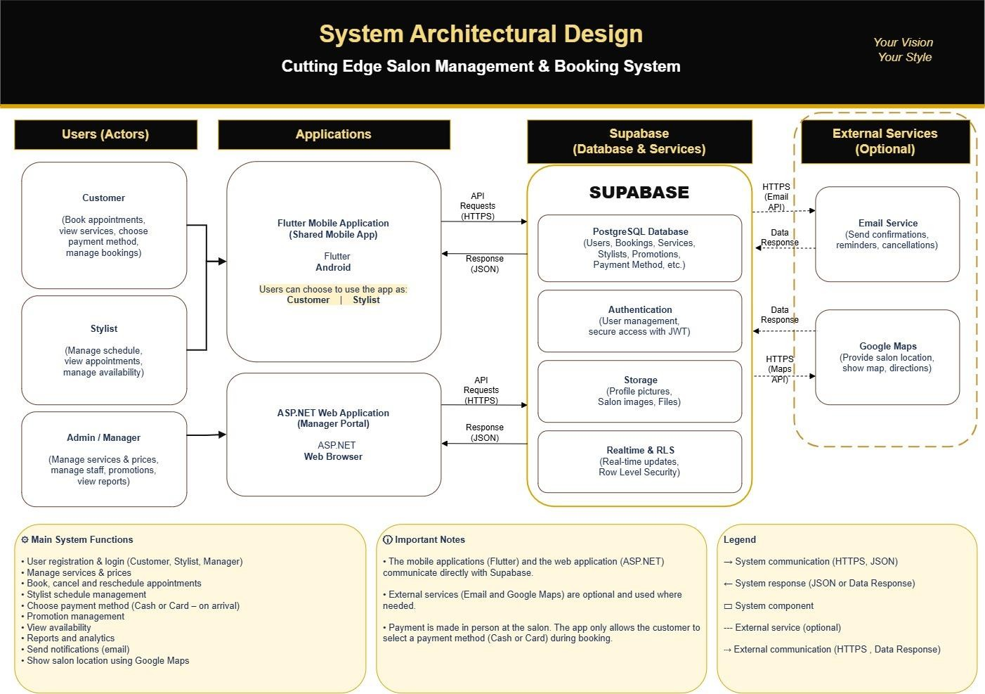
Figure 1: Final system architectural design – Customer and Stylist share one Flutter mobile application, while ASP.NET provides the Manager Portal; both use the shared Supabase backend.
- Architecture explanation
Customers and stylists use the same Flutter mobile application. When the application opens, the user selects whether they are using the system as a Customer or Stylist. The application then displays role-specific functionality. Customer functions focus on services, bookings, booking management, payment-method selection and salon location, while Stylist functions focus on viewing appointments and managing schedule/availability. The manager uses the ASP.NET web application as the administrative portal.
The shared Flutter mobile application and the ASP.NET web application use Supabase as the shared backend. Supabase Authentication handles account access, the PostgreSQL database stores shared application data, and Supabase Storage stores files/images where required. This shared backend ensures that information is available consistently to the relevant Customer, Stylist and Manager functions.
The system also integrates an Email Service for booking-related email notifications and Google Maps for the salon location. The payment choice stored with a booking is only the method the customer intends to use on arrival; no online transaction is processed.
• Activity 3.2 – UML and Database Design
- Actors and main use cases
Table 6: Actors and required functions

Actor | Main functions
Customer | Register, Login, View service catalogue & Pricing, View salon information/location, Book appointment, View appointment, Cancel or reschedule booking.
Stylist | Register, Login, View Appointment, Manage Availability.
Manager | Login with predefined/default credentials, Manage services & prices, Manage stylist profiles, Manage promotions, Manage all bookings, View Reports & Analytics, Manage Gallery Content.
- UML relationship rules used
The Use Case Diagram follows the UML relationship rules covered in the lecture material. An association shows that an actor directly interacts with a use case. The <<include>> relationship is used where another function is required as part of the main use case. The <<extend>> relationship is used where additional behaviour only occurs under a particular condition. Generalization is only used where an actor or use case is a specialised form of another; no generalization relationship is required in the current Use Case Diagram.
Table 7: Use case relationships applied in this project
Relationship | Project example | Meaning
Association | Customer — Book Appointment | The Customer directly performs the Book Appointment use case.
Association | Stylist — Manage Availability | The Stylist directly manages their availability.
Association | Manager — Manage Gallery Content | The Manager directly manages the salon gallery content.
<<include>> | Register → Verify User Account | Account verification is required as part of the registration process.
<<extend>> | Display Login Error → Login | The login error is displayed only when the Customer or Stylist login attempt fails.
<<extend>> | Display Login Error → Login (Default Credentials) | The login error is displayed if the Manager enters incorrect predefined/default credentials.
<<extend>> | View Location on Google Maps → View Salon Information/Location | The map is displayed when the Customer chooses to view the salon location.
<<include>> | Book Appointment → Check Stylist Availability | Stylist availability must be checked before the appointment can be completed.
<<include>> | Book Appointment → Validate Availability (Prevent Double Booking) | The selected date and time must be validated to prevent overlapping bookings.
<<include>> | Book Appointment → Select Payment Method | The Customer selects Cash or Card for payment on arrival as part of the booking process.
<<include>> | Book Appointment → Send Confirmation Email (Booking Details) | A confirmation email is sent after a successful booking is created.
<<include>> | Cancel or Reschedule Booking → Restore Availability | The previously reserved appointment slot is restored when the booking is cancelled or changed.
<<extend>> | Send Cancellation Email (Cancellation Details) → Cancel or Reschedule Booking | A cancellation email is sent only when the booking action results in a cancellation.

- Role-specific use case diagrams
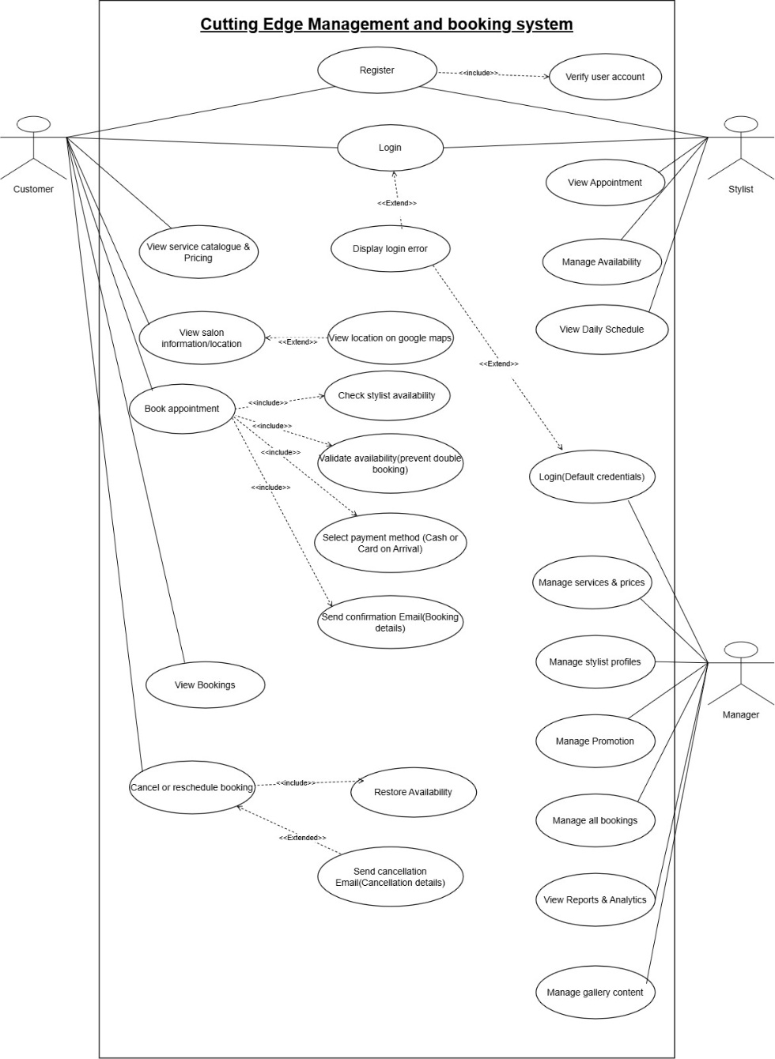

- The Customer can register and log in, view the service catalogue and pricing, view salon information and location, book an appointment, select a payment method, view bookings, and cancel or reschedule a booking.
- The Stylist can register and log in, view appointments, manage availability and view the daily schedule.
- The Manager logs in using predefined/default credentials and can manage services and prices, stylist profiles, promotions, all bookings, reports and analytics, and gallery content.

- Sequence diagrams
Three sequence diagrams are documented to represent the major Customer, Stylist and Manager interactions. Each sequence diagram is based on an approved use case and shows the actor, application, Supabase interaction, messages, responses and activation in the order in which they occur.Table 8: Sequence diagram coverage

Sequence diagram | Main participants | Process represented
Customer books appointment | Customer, Flutter Mobile  Application, Supabase  Authentication, Supabase  Database, Email Service, Google  Maps API | Login, availability request, booking, conflict handling, payment-method selection, confirmation and optional location view.
Stylist views schedule and manages availability | Stylist, Flutter Mobile Application,  Supabase Authentication,  Supabase Database | Login, retrieve daily appointments/schedule and update availability.
Manager manages salon information | Manager, ASP.NET Manager Portal,  Supabase Authentication, Supabase  Database | Login with predefined credentials, retrieve services, add/edit service data, and optionally manage promotions and gallery content with validation and save responses.

Figure 6: Customer sequence diagram – booking an appointment through the shared Flutter mobile application.
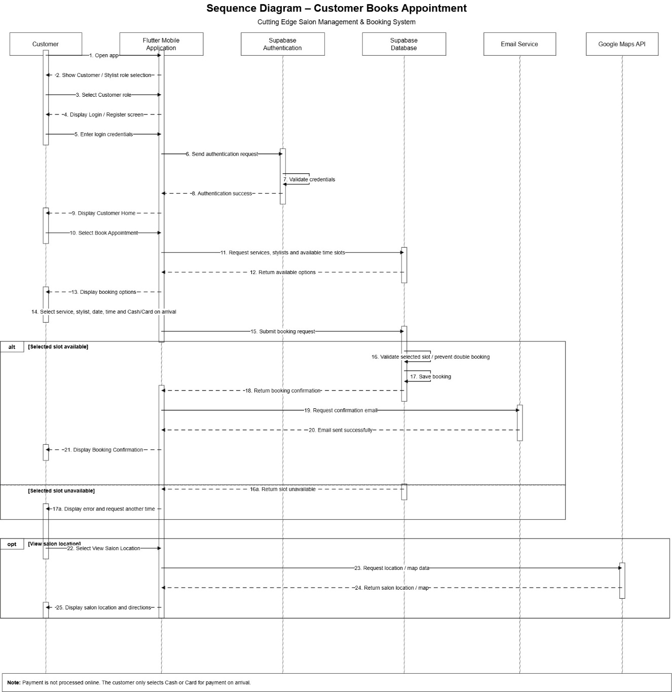
- | P a g e

Customer booking interaction
The customer logs into the Flutter application, requests available stylists/time slots, selects a service, stylist, date/time and payment method, and submits the booking. Supabase validates the slot to prevent double booking. If the slot is available, the booking is saved and a confirmation email is requested. If the slot is unavailable, the application displays an error and asks the customer to select another time. The Google Maps flow is optional and is used when the customer chooses to view the salon location.

- | P a g e Figure 7: Stylist sequence diagram – viewing schedule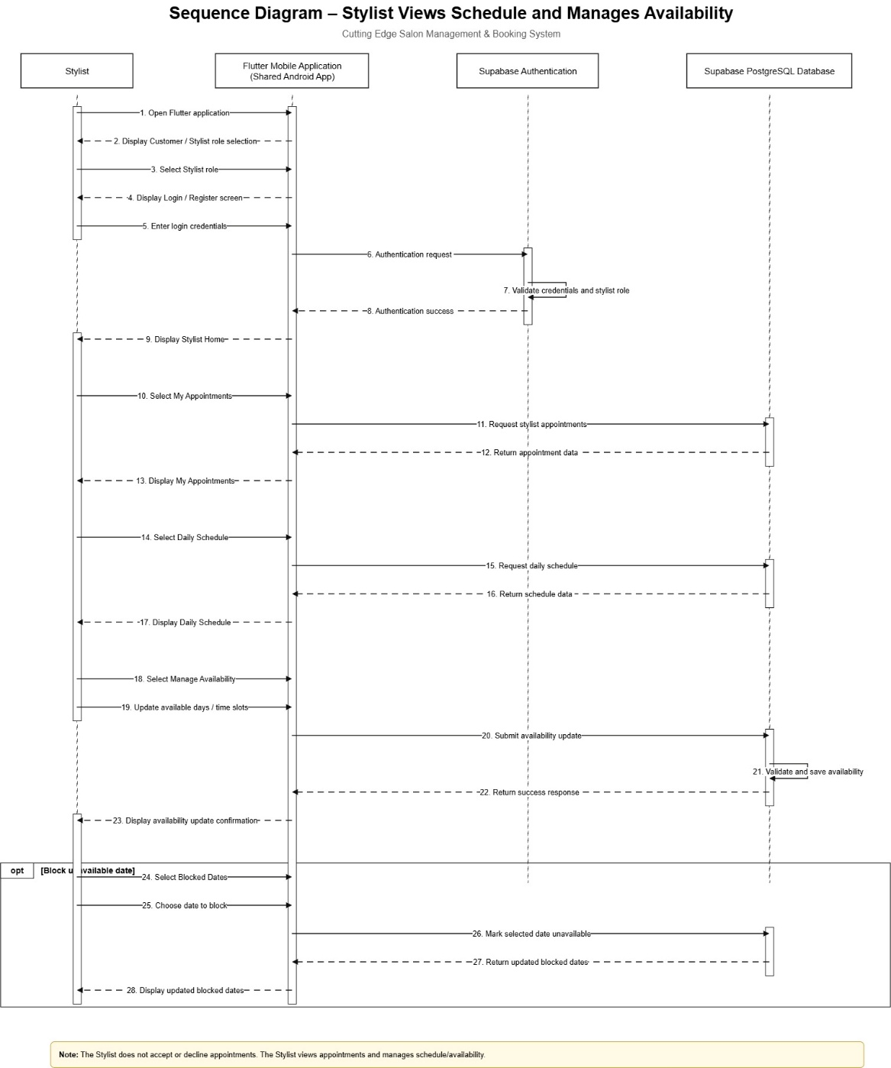

- | P a g e

Stylist schedule and availability interaction
The stylist selects the Stylist role in the Flutter mobile application, logs in, retrieves appointments and the daily schedule from Supabase, then updates available days/time slots when required. The updated availability is saved and a success response is returned. The diagram intentionally excludes accept/decline actions because these are not part of the final stylist responsibility.

- | P a g e

Figure 8: Manager sequence diagram – managing salon information through the ASP.NET Manager Portal.
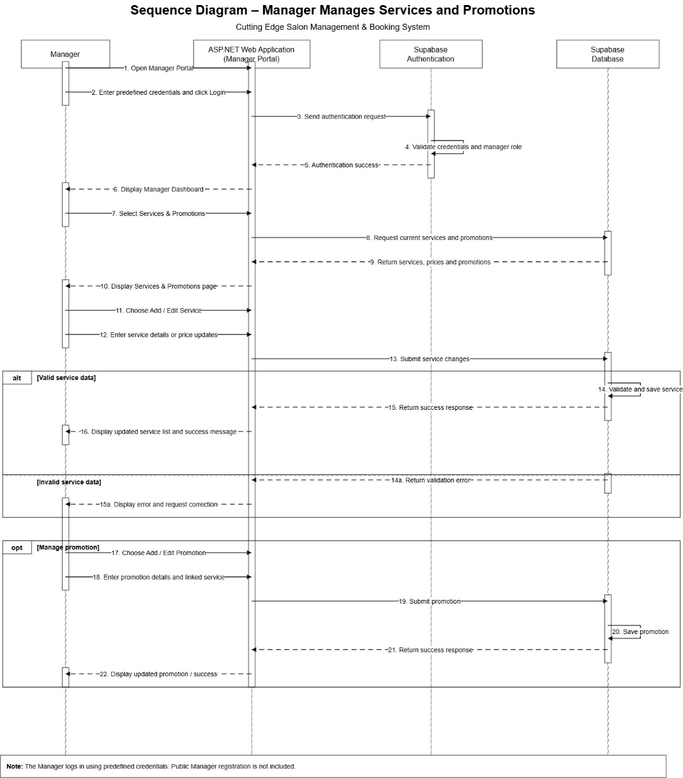
- | P a g e

Manager salon information management interaction
The manager opens the ASP.NET Manager Portal and logs in using the predefined credentials. After authentication, the manager retrieves the current service list and can add or edit service information. The diagram also includes optional flows for managing promotions and gallery content. Valid changes are stored in Supabase and the updated information is displayed. Invalid service data returns a validation error so the manager can correct the details.

o Database design

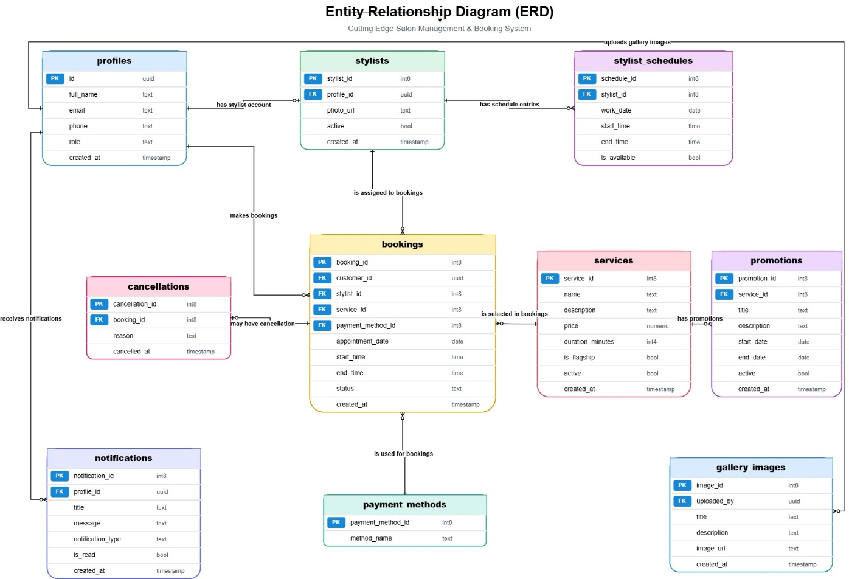
Figure 9: Entity Relationship Diagram (ERD) – proposed database structure for the Cutting Edge Salon Management & Booking System.

4.5.1 Entity Relationship Diagram Explanation
The Entity Relationship Diagram (ERD) shows the proposed database structure for the Cutting Edge Salon
Management & Booking System. The database will be implemented using Supabase PostgreSQL and will store the information required by the Customer, Stylist and Manager functions. The bookings table acts as one of the central entities because it connects customers, stylists, services and payment methods while storing the appointment date, start time, end time and booking status.

Entity | Purpose
profiles | Stores the general user information such as full name, email address, phone number and role. The id field is the primary key and uses a UUID.
stylists | Stores information specifically related to stylists. Each stylist is linked to a profile through profile_id. It also stores the stylist's photo and whether the stylist is currently active.
stylist_schedules | Stores the working schedule and availability of each stylist. It contains the work date, start time, end time and whether the stylist is available.
bookings | Stores appointment information. It links the customer, stylist, service and selected payment method, and stores the appointment date, start time, end time, booking status and creation date.
services | Stores the salon services offered to customers, including service name, description, price, duration and whether a service is the flagship service.
payment_methods | Stores the available payment-method choices. In this system, these are Cash and Card. The selected method only indicates how the customer intends to pay when arriving at the salon; payment is not processed through the application.
cancellations | Stores cancellation information for a booking, including the reason and date/time of cancellation.
promotions | Stores promotional offers created for salon services, including the promotion title, description, start date, end date and whether the promotion is active.
gallery_images | Stores salon and hairstyle images that can be displayed in the application's gallery. It contains the uploaded_by reference, image title, description, image URL and creation date.
notifications | Stores user notification information, including the related profile, title, message, notification type, read status and creation date.

- The profiles and stylists relationship allows the system to keep common user information in the profiles table while storing stylist-specific information separately. A profile may belong to a stylist, and the stylist record uses profile_id as a foreign key to identify the related profile.

- The stylists and stylist_schedules relationship allows one stylist to have several schedule records. This enables the stylist to manage different working dates and time periods. The is_available field determines whether a particular schedule period is available for customer bookings.

- The bookings table connects the main booking information. The customer_id identifies the customer making the booking, stylist_id identifies the selected stylist, service_id identifies the requested service, appointment_date, start_time and end_time store the appointment period, and payment_method_id identifies whether the customer selected Cash or Card for payment on arrival. The booking also stores its status and creation timestamp.

- The relationship between profiles and bookings allows one customer profile to have multiple bookings over time. This supports the customer's ability to view current and previous appointments.

- The relationship between stylists and bookings allows a stylist to be associated with multiple appointments. This enables the stylist to view appointments assigned to their schedule through the shared Flutter mobile application.

- The relationship between services and bookings means that every booking refers to a salon service. One service can therefore appear in many different bookings. Information such as the service name, price and duration does not need to be duplicated inside every booking record.

- The relationship between payment_methods and bookings allows the customer's chosen payment method to be stored with the appointment. For example, if the customer selects Card, the booking stores the corresponding payment-method reference. This is a payment preference only and does not represent an online transaction.

- A booking can also have a related record in the cancellations table. The cancellation
record stores information such as the cancellation reason and the time at which the booking was cancelled. Keeping cancellation information separately makes it possible to maintain a history of cancellations while the booking itself can have its status updated to indicate that it has been cancelled.

- The services and promotions relationship allows promotions to be linked to salon services. One service can have multiple promotions over time. This supports the manager's ability to create promotions such as discounts or special offers for particular services, including the salon's flagship services.

- The gallery_images table stores image information separately from the transactional booking data. Images themselves can be stored using Supabase Storage, while the database can store information such as the image title, description and URL.

- Overall, the ERD supports the major functions of the proposed system. Customers can register, book appointments, select a payment method and cancel bookings; stylists can view their appointments and manage availability; and the manager can manage services, stylist profiles, promotions, bookings, reports and gallery-related information. The database therefore provides a shared data structure used by both the Flutter mobile application and the ASP.NET Manager Portal.

Named relationships together with their cardinalities

Relationship name | Entities | Cardinality | Meaning
has stylist account | profiles → stylists | 1 : 0..1 | One profile may have one stylist account, but not every profile is a stylist.
has schedule entries | stylists → stylist_schedules | 1 : 0..* | One stylist can have zero or many schedule records. Each schedule record belongs to one stylist.
makes bookings | profiles → bookings | 1 : 0..* | One customer profile can make zero or many bookings. Each booking belongs to one customer profile.
is assigned to bookings | stylists → bookings | 1 : 0..* | One stylist can be assigned to zero or many bookings. Each booking is assigned to one stylist.
is selected in bookings | services → bookings | 1 : 0..* | One service can be selected in zero or many bookings. Each booking selects one service.
may have cancellation | bookings → cancellations | 1 : 0..1 | One booking may have no cancellation record, or one cancellation record if it is cancelled.
is used for bookings | payment_methods → bookings | 1 : 0..* | One payment method, such as Cash or Card, can be used by many bookings. Each booking stores one payment method.
has promotions | services → promotions | 1 : 0..* | One service can have zero or many promotions. Each promotion belongs to one service.
receives notifications | profiles → notifications | 1 : 0..* | One profile can receive zero or many notifications. Each notification belongs to one profile.
uploads gallery images | profiles → gallery_images | 1 : 0..* | One authorised profile, normally the manager, can upload zero or many gallery images. Each gallery image records one uploader.

Activity 3.3 – Interface Design Baseline

Review of approved design inputs

Table 9: Design inputs reviewed
Design input | How it guides the interface baseline
Approved requirements and role functions | Define what Customer, Stylist and Manager must be able to do.
System architecture | Confirms that Customer and Stylist use the shared Flutter app, Manager uses ASP.NET, and both use Supabase.
Use Case Diagram | Identifies the functions that must be available to the correct actor.
Sequence diagrams | Define the order of the customer booking, stylist availability, and manager salon-information interactions, including the optional promotion and gallery flows shown in the Manager sequence.
ERD / database design | Defines the information that can be captured, stored and displayed by the interfaces.
Flutter and ASP.NET wireframes | Provide the proposed layout, navigation, controls, tables/lists and user actions.

Required Flutter mobile screens

Table 10: Required Flutter interface screens
Flutter screen |  | User |  | Purpose |  | Related requirement / use case
Role Selection / Welcome |  | Customer & Stylist |  | Select Customer or Stylist role before entering role-specific flow. |  | Shared Flutter role-selection decision
Login / Register |  | Customer & Stylist |  | Authenticate existing users or  create an account. |  | Register; Login
Forgot Password / Verify Account |  | Customer & Stylist |  | Support account recovery and verification. |  | Authentication  support
Customer Home |  | Customer |  | Access services, team, bookings, promotions and salon information. |  | Access customer functions
Services & Pricing |  | Customer |  | View service catalogue, prices  and service information. |  | View Service Catalogue &  Pricing
Service Selection / Detail |  | Customer |  | Choose a service before  booking. |  | Book Appointment
Book Appointment |  | Customer |  | Choose service, stylist, date/time and Cash/Card for payment on arrival. |  | Book  Appointment;  Select Payment  Method
Booking Confirmation |  | Customer |  | Show the confirmed booking after successful validation and storage. |  | Book  Appointment;  Send  Confirmation  Email
My Bookings |  | Customer |  | View upcoming/current bookings and access booking management. |  | View Own Booking
Salon  Information /  Location |  | Customer |  | View salon information and open the location in Google Maps. |  | View Salon Information /  Location
Our Team |  | Customer |  | View stylist profiles to support  stylist selection. |  | View stylist  information
Profile / Edit Profile |  | Customer & Stylist |  | View and update permitted  profile information. |  | Account/profile  support
Stylist Home |  | Stylist |  | Access appointment, schedule  and availability functions. |  | Stylist role  functions
My  Appointments |  | Stylist |  | View assigned/upcoming  appointments. |  | View Appointment
 | Appointment Details |  | Stylist |  | View the details of a selected  appointment. |  | View Appointment
 | Daily Schedule |  | Stylist |  | View daily appointment schedule and available periods. |  | View Appointment  Schedule
 | Manage Availability |  | Stylist |  | Set available days and working  time slots. |  | Manage Availability
 | Blocked Dates |  | Stylist |  | Mark dates unavailable when  required. |  | Manage Availability
 | Notifications |  | Customer & Stylist |  | View system notifications and  reminders. |  | Notification  support
 | Help & Support / Settings / Logout |  | Customer & Stylist |  | Provide support, preferences  and secure session exit. |  | Usability and  account support
 | Notification Details |  | Customer  & Stylist |  | Display the selected notification message and related information. |  | Notification support
 | My Earnings |  | Stylist |  | View earnings information presented in the Stylist interface. |  | Stylist interface support
 | All  Transactions |  | Stylist |  | View transaction information presented in the Stylist interface. |  | Stylist interface support

Required ASP.NET web pages

Table 11: Required ASP.NET Manager Portal pages
ASP.NET page |  | User Purpose |  |  |  | Related requirement / use case
Manager Login |  | Manager |  | Authenticate the Manager using predefined credentials. |  | Login
Dashboard |  | Manager |  | View summary information and access administration functions. |  | Manager  administration
Bookings |  | Manager |  | View and manage all salon bookings. |  | Manage All Bookings
Booking Details |  | Manager |  | View detailed booking information and permitted booking actions. |  | Manage All Bookings
Schedule |  | Manager |  | View stylist schedules and current working periods. |  | Manage stylist information / schedules
Add / Edit Schedule |  | Manager |  | Maintain stylist schedule information where authorised. |  | Schedule administration
Services & Promotions |  | Manager |  | View current services, prices and promotions. |  | Manage  Services &  Prices;  Manage  Promotions
New / Edit Service |  | Manager |  | Add or update service details, price and related information. |  | Manage  Services &  Prices
New / Edit Promotion |  | Manager |  | Create or update a promotion linked to a service. |  | Manage  Promotions
Stylists |  | Manager |  | View stylist profiles. |  | Manage  Stylist Profiles
Add / Edit Stylist |  | Manager |  | Create or update stylist-profile information. |  | Manage  Stylist Profiles
Reports |  | Manager |  | View reporting and analytics information. |  | View Reports & Analytics
 | Gallery |  | Manager |  | View salon images and upload/manage gallery content. |  | Gallery  management support
 | My Profile |  | Manager |  | View/update permitted Manager profile information. |  | Account support
 | Forgot  Password /  Create New Password |  | Manager |  | Support exceptional credential recovery/change. |  | Authentication support; not a normal operational use case
 | All Reviews |  | Manager |  | View customer reviews in the Manager Portal. |  | Manager portal interface support
 | Follow Up |  | Manager |  | Access follow-up information/actions shown in the Manager Portal. |  | Manager portal interface support

Interface wireframes
Figure 10: Flutter mobile interface wireframes – shared Customer/Stylist application.
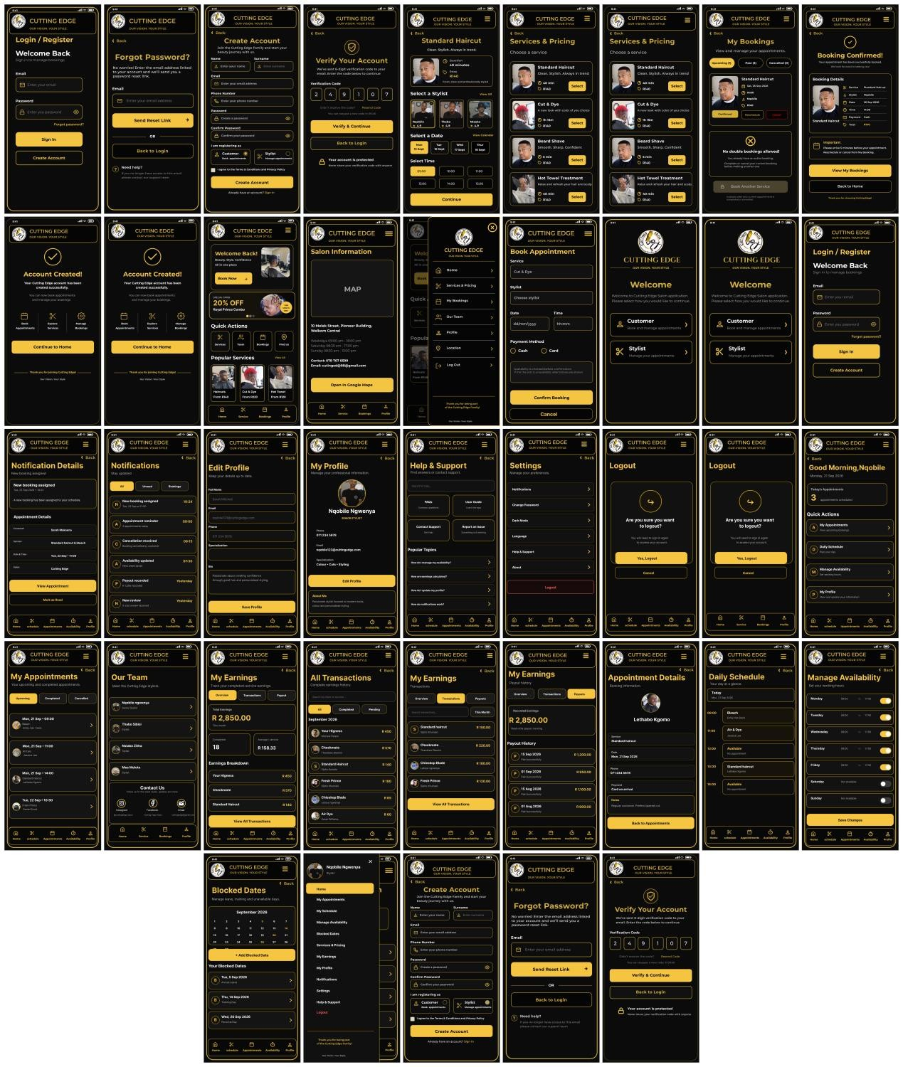
The Flutter interface set covers shared authentication and role selection, Customer service/booking/location functions, and Stylist appointment/schedule/availability functions. It also contains profile, notification, settings, help, blocked-date, earnings and transaction screens shown in the wireframes.

Figure 11: ASP.NET Manager Portal interface wireframes.
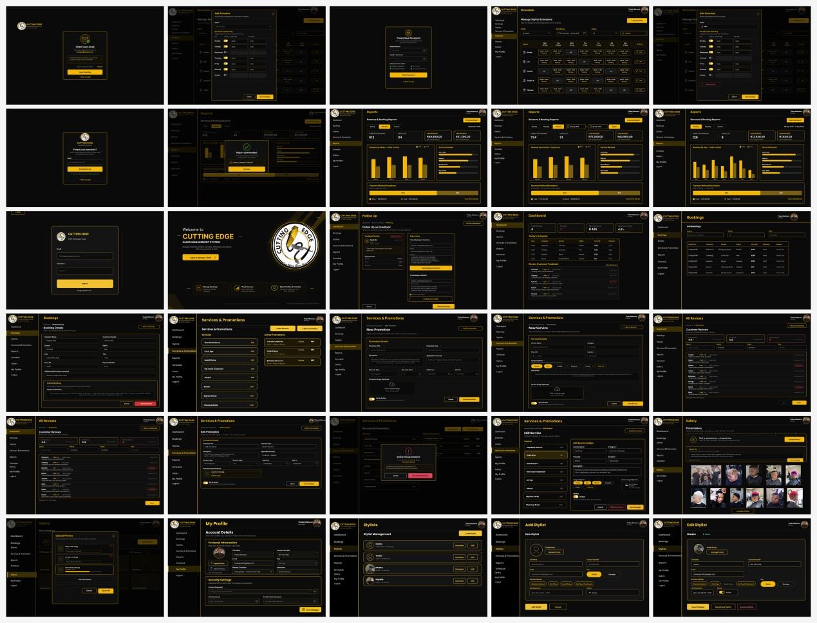
The ASP.NET interface set covers Manager authentication, dashboard, bookings, schedules, services/promotions, reports, gallery, stylist-profile administration, reviews and follow-up functions, together with supporting account pages.

Navigation between screens

Table 12: Main interface navigation flow
Starting screen |  | User action Next screen
Role Selection |  | Choose Customer |  | Customer Login / Register
Role Selection |  | Choose Stylist |  | Stylist Login / Register
Customer Login |  | Successful login |  | Customer Home
Customer Home |  | Select Services |  | Services & Pricing
Services & Pricing |  | Select service / Book |  | Book Appointment
Book Appointment |  | Submit valid booking |  | Booking Confirmation
Customer Home |  | Open My Bookings |  | My Bookings
My Bookings |  | Select a booking |  | Booking Details / booking management
Customer Home |  | Select Find Us / salon information |  | Salon Information / Google Maps
Stylist Login |  | Successful login |  | Stylist Home
Stylist Home |  | Select My Appointments |  | My Appointments
My Appointments |  | Select appointment |  | Appointment Details
Stylist Home |  | Select Daily Schedule |  | Daily Schedule
Stylist Home |  | Select Manage Availability |  | Manage Availability
Manage Availability |  | Save changes |  | Availability update confirmation / return to schedule
Manager Login |  | Successful login |  | Dashboard
Dashboard |  | Open Bookings |  | Bookings
Dashboard |  | Open Services & |  | Services & Promotions
 |  |  | Promotions
 | Services & Promotions |  | Add/Edit service or promotion |  | New/Edit Service or Promotion
 | Dashboard |  | Open Stylists |  | Stylist Management
 | Stylist Management |  | Add/Edit stylist |  | Add/Edit Stylist
 | Dashboard |  | Open Reports |  | Reports
 | Dashboard |  | Open Gallery |  | Gallery
 | Stylist Home |  | Open My Earnings |  | My Earnings
 | Stylist Home |  | Open All Transactions |  | All Transactions
 | Stylist Home |  | Open Notifications |  | Notifications
 | Notifications |  | Select a notification |  | Notification Details
 | Dashboard |  | Open All Reviews |  | All Reviews
 | Dashboard |  | Open Follow Up |  | Follow Up

Mobile and web integration check
Flutter and ASP.NET are parts of one integrated system rather than independent projects. Both applications use the same Supabase backend, so changes made by one application can be retrieved by the other where the user role is authorised to view the information.

Table 13: Flutter–Supabase–ASP.NET integration check
Flutter / user action | Supabase data | ASP.NET / integrated result
Customer creates a booking in Flutter | Booking, customer, stylist, service and payment-method references plus appointment date/time, status and creation data are stored. | Manager can view the booking in the ASP.NET Bookings pages.
Customer cancels/reschedules a booking | Booking status and cancellation record are updated; availability can be restored. | Manager sees the updated booking/cancellation information.
Stylist updates availability in Flutter | stylist_schedules availability  information is updated. | Manager can view current schedule information; Customer booking flow uses the updated availability.
Manager updates service/price in  ASP.NET | services record is updated. | Flutter Services & Pricing retrieves the updated service information.
Manager creates/updates a promotion | promotions record is  created/updated. | Flutter can display the approved promotion in relevant Customer views.
Manager adds/edits a stylist | profiles/stylists information is  created/updated. | Flutter can show current stylist information to  Customers and the Stylist role.
Manager uploads gallery content | Image is stored in Supabase Storage and the image reference/metadata is stored for the gallery. | Flutter can display salon/gallery images to  Customers where required.

Payment integration note: Cash or Card is only stored as the customer’s intended payment method for payment on arrival at the salon. No online payment transaction is performed by the application.

Interface-to-ERD alignment

Interface information | Entity / table | Attribute / field
Registration / Profile | profiles | id, full_name, email, phone, role, created_at
Stylist profile / team | stylists | stylist_id, profile_id, photo_url, active,  created_at
Services & Pricing | services | service_id, name, description, price,  duration_minutes, is_flagship, active
Stylist schedule / availability | stylist_schedules | schedule_id, stylist_id, work_date, start_time,  end_time, is_available
Book  Appointment / My  Bookings | bookings | booking_id, customer_id, stylist_id,  service_id, payment_method_id, appointment_date, start_time, end_time, status, created_at
Payment-method selection | payment_methods | payment_method_id, method_name
Cancellation | cancellations | cancellation_id, booking_id, reason,  cancelled_at
Promotions | promotions | promotion_id, service_id, title, description,  start_date, end_date, active, created_at
Gallery | gallery_images | image_id, uploaded_by, title,  description, image_url, created_at
Notifications | notifications | notification_id, profile_id, title,  message, notification_type, is_read, created_at

Supabase Storage is used for the physical image files where required, while the database stores the corresponding image references/metadata used by the interfaces.

Stakeholder interface feedback record

Table 15: Stakeholder interface feedback record
Item |  | Details
Date of feedback |  | 20 September 2026
Designs shown |  | The stakeholder was shown the updated System  Architecture Diagram, Use Case Diagram,  Customer/Stylist/Manager Sequence Diagrams, ERD,  Flutter mobile interface designs, and ASP.NET Manager Portal wireframes. The Flutter designs included role selection, authentication, services, booking, appointments, stylist schedule, availability, profile, notifications, earnings, transactions and salon information. The ASP.NET designs included the manager dashboard, booking management, schedules, stylist management, services and prices, promotions, gallery management, reports, reviews and follow-up functions.
Stakeholder |  | The stakeholder indicated that the overall design reflects the salon's
 | comments |  | requirements and is easy to understand. They were satisfied that customers and stylists use the same mobile application but receive different functions according to their selected role. The stakeholder also approved the black-and-gold visual style because it represents the salon's desired luxury image. The booking process was considered clear, especially the ability for customers to view available stylists, select a service, date and time, and select either Cash or Card for payment on arrival. The manager portal was considered suitable for managing salon information, bookings, services, stylist profiles, promotions and reports.
 | Changes requested |  | The stakeholder requested that the system clearly show salon promotions to customers on the Flutter home screen. They also requested that salon/gallery pictures be easy to upload and display. The stylist interface should remain simple and should focus on viewing appointments and managing availability rather than approving or rejecting bookings. The customer booking process should clearly state that selecting Cash or Card does not mean payment is made through the application.
 | Changes made |  | A promotion section/banner was added to the customer home screen. Gallery functionality was included so salon images can be stored and displayed. The stylist design was updated so the stylist only views appointments and manages schedule/availability, with accept/decline functionality removed. The booking interface and system documentation were updated to explain that the customer selects a preferred payment method but pays physically at the salon. Customer and Stylist were also consolidated into one shared Flutter application with role selection, while the Manager remains on the ASP.NET web portal.
 | Evidence available |  | See the photographic evidence below.

Table 16: Evidence of stakeholder meet-up
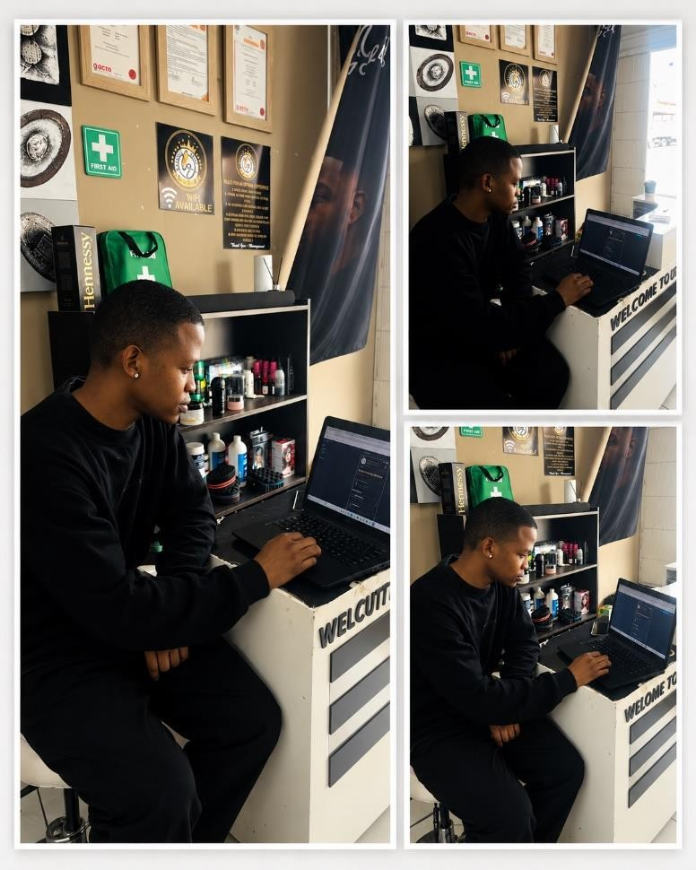

System-design update record

Design Artefact | Change made | Reason
Architecture | Clarified that the customer only selects Cash or Card as a payment method for payment on arrival. No online payment gateway is included. | To match the stakeholder requirement and prevent users from thinking that payment is processed through the application.
Use Case Diagram | Manager registration was removed as a normal use case. The Manager logs in using predefined/default credentials | The Manager account is not created through public registration. Credentials are predefined and only changed when management changes.
Sequence Diagrams | Customer booking flow was updated to show the customer  selecting a service, stylist, date/time and Cash/Card payment method, followed by availability validation before the booking is stored | To clearly show double-booking prevention and the correct order of the approved booking process.
ERD | Payment method information was separated into a payment_methods structure and referenced by bookings rather than representing an online payment transaction | To support Cash/Card selection while maintaining the rule that actual payment happens physically at the salon.
Flutter Interface | A promotion section/banner was added to the Customer home screen. | The stakeholder requested that promotions be visible to customers and that important salon offers be promoted clearly
ASP.NET Interface | The Manager interface uses login with predefined credentials rather than a public Manager registration process. | Ensures the interface matches the Manager use case and sequence diagrams, where predefined credentials are used.

Cross-Design Alignment and Traceability
The following traceability check confirms how the current approved functions are represented across the design artefacts. Where a function is not the subject of one of the three selected sequence diagrams, the table records that it is supported by the architecture, ERD and interface baseline without claiming a sequence diagram that does not exist.
Table 18: Customer and Stylist cross-design alignment
Approved function | Use case /  role evidence | Sequenc e evidence | ERD support | Interface  evidence
Register / Login | Customer or  Stylist authentication | Authentication is shown in  The Customer and  Stylist  sequence  . | profiles / Supabase Authentication | Login,  Register,  Verify  Account
View services & pricing | Customer views service catalogue | Used before the booking interaction | services | Services & Pricing
Book appointment | Customer books appointment | Customer booking sequence | bookings, services, stylists, stylist_schedules | Book Appointent,  Booking Confirmati on
Prevent double booking | Validate  Availability /  Prevent  Conflict | Customer booking sequence validates selected slot. | bookings +stylist_schedules | Booking flow / unavailabl e-slot feedback
Select Cash/Car d | Select Payment  Method | Customer booking sequence includes paymentmethod selection. | payment_methods +  bookings.payment_met  hod_id | Book  Appointm ent
View /  manage own booking | View Own  Booking; Cancel/Reschedule | Booking  management is supported by the  Customer flow; cancellation has no separate sequence in current set. | bookings, cancellations | My Bookings
View salon location | View Salon Information /  Location | Optional location interaction is  shown in Customer sequence  . | External Google Maps service / salon location data | Salon Information /  Google  Maps
View  stylist  appointments | View Appointment | Stylist  sequence retrieves appointm ents and daily schedule. | bookings, stylists | My Appointm  ents,  Appointm ent Details
Manage  availability | Manage Availability | Stylist  sequence updates  availabilit y. | stylist_schedules | Daily  Schedule,  Manage  Availabilit y, Blocked Dates

Table 19: Manager cross-design alignment
Approved function | Use case / role evidence | Sequence evidence | ERD support | Interface  evidence
Manager login | Login with predefined credentials | Manager salon information sequence begins with authentication using predefined credentials. | Supabase  Authentication / profile role | Manager Login
Manage  services & prices | Manage Services &  Prices | Manager saloninformation sequence – Services &  Prices flow. | services | Services & Promotion  s;  New/Edit  Service
Manage stylist profiles | Manage  Stylist  Profiles | Not separately modelled in current sequence set. | profiles,  stylists | Stylists; Add/Edit  Stylist
Manage promotions | Manage Promotions | Manager salon information sequence – optional  Manage Promotions flow. | promotions,  services | Services & Promotions;  New/Edit  Promotion
Manage all  bookings | Manage All Bookings | Not separately modelled in current sequence set. | bookings,  cancellations | Bookings;  Booking  Details
View reports & analytics | View Reports &  Analytics | Not separately modelled in current sequence set. | bookings,  services, stylists and derived report data | Reports
Manage gallery content | Gallery  management  support | Manager salon information sequence – optional  Manage  Gallery flow. | gallery_images + Supabase  Storage | Gallery / uploadphoto interface

Project Scheduling
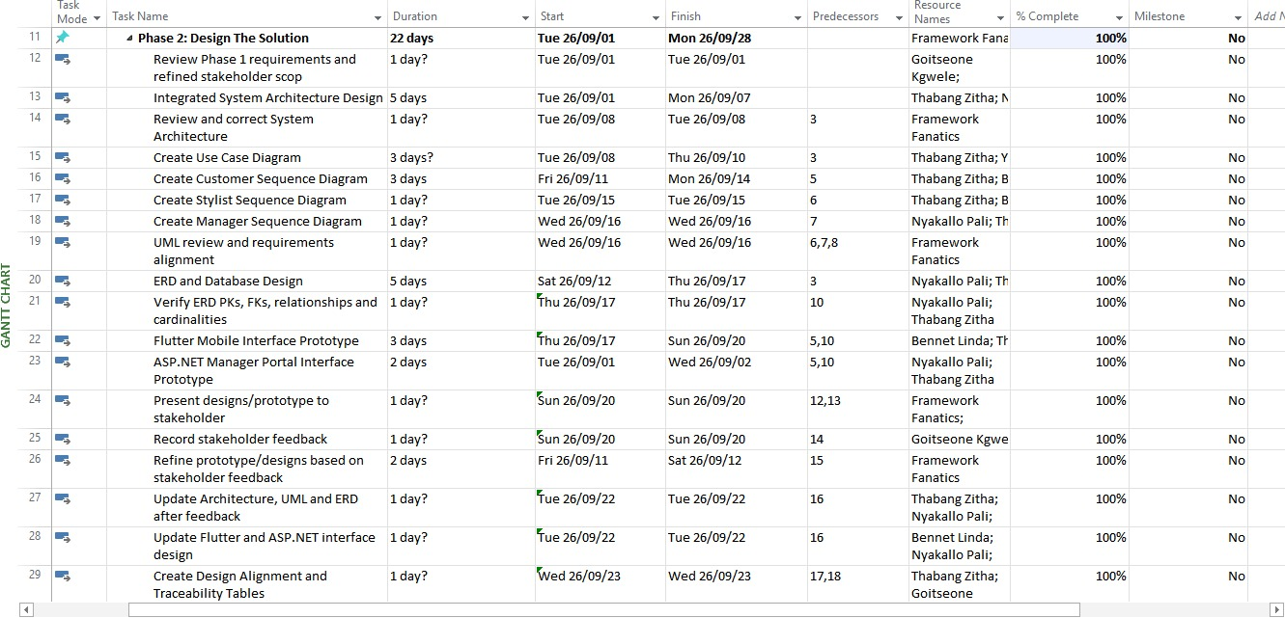

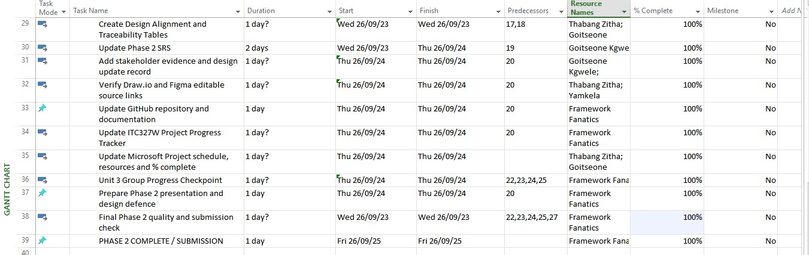

Project Overview and Program Dashboard

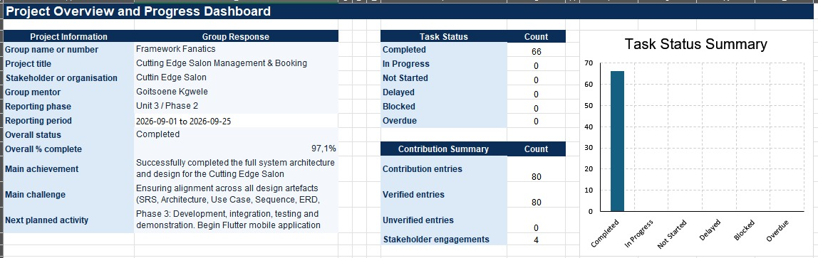

Project Progress Tracker summary GitHub repository

GitHub item | Entry
Working repository link | https://github.com/Yamkela47/Group-B-

Original design source links / editable files

Artifact | Displayed/evidence file | Tool / source type | Working link / editable source
System Architecture | System Architecture FINAL.jpg | draw.io | https://viewer.diagrams.net/?tags=%7B%7D&lightbox=1&highlight=0000ff&edit=_blank&layers=1&nav=1&title=System%20Architecture.drawio&page-id=juYFnv_ws_8BTg2olr6R&dark=auto#Uhttps%3A%2F%2Fdrive.google.com%2Fuc%3Fid%3D1pJVlU_18ErRvNwdjZuR7ssZGRu3SWMDU%26export%3Ddownload
Use Case Diagram | USECASE Cutting edge.jpg | draw.io | https://viewer.diagrams.net/?tags=%7B%7D&lightbox=1&highlight=0000ff&edit=_blank&layers=1&nav=1&title=System%20Architecture.drawio&page-id=juYFnv_ws_8BTg2olr6R&dark=auto#Uhttps%3A%2F%2Fdrive.google.com%2Fuc%3Fid%3D1pJVlU_18ErRvNwdjZuR7ssZGRu3SWMDU%26export%3Ddownload
Sequence diagrams | Customer Sequence.jpg; Stylist sequence.jpg; Manager sequence.jpg | draw.io | https://viewer.diagrams.net/?tags=%7B%7D&lightbox=1&highlight=0000ff&edit=_blank&layers=1&nav=1&title=Stylist%20Architecture.drawio&dark=auto#Uhttps%3A%2F%2Fdrive.google.com%2Fuc%3Fid%3D1KJAE8kFhFTD1jMvd7st_SqDiU073QpRD%26export%3Ddownload
ERD | Cutting Edge ERD.jpg | draw.io | https://viewer.diagrams.net/?tags=%7B%7D&lightbox=1&highlight=0000ff&edit=_blank&layers=1&nav=1&title=ERD%20WITH%20RELATIONSHIPS.drawio&dark=auto#Uhttps%3A%2F%2Fdrive.google.com%2Fuc%3Fid%3D1yQ2pFT0kolKY4KEmoG521TZJnQNzxdY_%26export%3Ddownload
Flutter interface designs | flutter wireframe.docx | Figma | https://www.figma.com/proto/wplE9g15S1lt4ZcGnG9z4 Y/Login-Screen?node-id=0-1
ASP.NET interface designs | asp.net wireframe.docx | Figma | https://www.figma.com/design/TejK6RcG91RgeUDwU2D QIn/Cutting-Edge?node-id=0 1&p=f&t=muu2NgZNcm6Pe6HZ-0
Stakeholder evidence | Evidence phase 2/evidence stakeholder.png | Photo | Included in submission package

References
Cai, A. 2025. Figma Wireframe Tutorial for Beginners [YouTube video]. 22 January. Available at: https://www.youtube.com/watch?v=iyrEStiTZh0 [Accessed 25 September 2026].
Central University of Technology. 2026. ITC327W Unit 3: System Architecture and Design. Work-Integrated Learning in Information Technology. Internal eThuto/Blackboard learning material. [Accessed 25 September 2026].
Geekific. 2021. UML Use-Case and Sequence Diagrams Made Simple | Step by Step Guide | UML Diagrams [YouTube video]. 21 August. Available at: https://www.youtube.com/watch?v=el501qi0KtI [Accessed 25 September 2026].
Google. 2026. Flutter documentation. Available at: https://docs.flutter.dev/ [Accessed 25 September 2026].
Google. 2026. Google Maps Platform Documentation. Available at: https://developers.google.com/maps/documentation [Accessed 25 September 2026].
Lucid Software. 2017. Entity Relationship Diagram (ERD) Tutorial - Part 1 [YouTube video]. 6 March. Available at: https://www.youtube.com/watch?v=QpdhBUYk7Kk [Accessed 25 September 2026].
Lucid Software. n.d. UML Use Case Diagram Tutorial. Available at: https://www.lucidchart.com/pages/umluse-case-diagram [Accessed 25 September 2026].
Microsoft. 2025. Overview of ASP.NET Core. Microsoft Learn. Available at: https://learn.microsoft.com/enus/aspnet/core/overview [Accessed 25 September 2026].
Supabase. 2026. Supabase Documentation. Available at: https://supabase.com/docs [Accessed 25 September 2026].

- References
The following academic works provided a theoretical and practical framework for this project, particularly concerning the structure of the SRS, feasibility analysis, risk management, and the principles of WorkIntegrated Learning (WIL) that underpin the module.

Academic Sources
  - Kendall, K. E., & Kendall, J. E. (2020). Systems Analysis and Design (10th ed.). Pearson.
Context of Use: This foundational text provided the framework for structuring the requirements analysis sections of this SRS, including the Problem Statement, Functional Requirements, and the use of the MoSCoW prioritisation technique. The book's guidance on feasibility studies (technical, operational, economic, schedule, legal, and ethical) directly informed the comprehensive feasibility analysis conducted in Unit 2.
  - Wiegers, K. E., & Beatty, J. (2013). Software Requirements (3rd ed.). Microsoft Press.
Context of Use: This source was instrumental in defining the functional and non-functional requirements (Sections 12 and 13). It provided best practices for writing clear, testable requirements and establishing acceptance criteria (Section 6). The MoSCoW prioritisation framework used in Section 16 was also derived from the principles outlined in this text.
  - Sommerville, I. (2016). Software Engineering (10th ed.). Pearson.
Context of Use: This comprehensive software engineering textbook provided guidance on system modelling and process flow documentation (Section 9). The concepts of system interfaces, product perspective (Section 10), and integration requirements (Section 15) were framed using the principles outlined in this work.
  - Schwalbe, K. (2018). Information Technology Project Management (9th ed.). Cengage Learning.
Context of Use: This source provided the framework for the project risk register (Section "Prepare a Project Risk Register") and the feasibility analysis. The risk identification, assessment, and mitigation strategies documented in the risk register follow the project management best practices outlined in this text.
  - Pressman, R. S. (2014). Software Engineering: A Practitioner's Approach (8th ed.). McGraw-Hill Education.
Context of Use: This text informed the system requirements (Section 14) and the integration requirements (Section 15). The practical approach to software development described in this work influenced our decision to prioritise core "Must Have" requirements and simplify lowerpriority features to ensure successful project completion within the semester.
  - Bourque, P., & Fairley, R. E. (Eds.). (2014). Guide to the Software Engineering Body of Knowledge (SWEBOK) (3rd ed.). IEEE Computer Society.
Context of Use: This internationally recognised guide was referenced for the software requirements engineering knowledge area, particularly regarding requirements elicitation, analysis, and specification. It provided the structure for documenting stakeholder needs (Section 8) and validating requirements through stakeholder confirmation (Appendix C).
  - Rouse, M., & Levene, A. (2018). Work Integrated Learning (WIL) in Information Technology: A South African Perspective. Journal of Information Technology Education: Research, 17, 185-204.
Context of Use: This South African-focused study provided the educational context for this WIL project. It helped frame the project within the ITC327W module's learning outcomes and justified the real-world application of theoretical knowledge through the development of the Cutting Edge Salon Management & Booking System.

- Acknowledgment of Lecture Materials
The structure and content of this SRS were significantly guided by the lecture slides and course materials provided for the module ITC327W – Work Integrated Learning in Information Technology.
  - Unit 1: Planning and Requirements Analysis provided the foundational framework for this document, outlining the expected sections, such as the Problem Statement,
Project Scope, Functional Requirements (FR-01 to FR-18), Non-Functional
Requirements (NFR-01 to NFR-08), and the use of the MoSCoW prioritisation technique (Section 16). The structure of the appendices containing stakeholder evidence was also guided by these materials.
  - Unit 2: Feasibility and Risk Analysis directly informed the feasibility study and risk register sections. The lecture content on conducting technical, operational, economic, schedule, legal, and ethical feasibility studies provided the framework for evaluating each feasibility area and making the overall feasibility decision. The process of creating and managing a Project Risk Register was followed as outlined in the course materials.
  - Assessment Guidelines: The format and structure of the deliverables, including the SRS document, Project Progress Tracker, and Microsoft Project schedule, followed the guidelines provided by Mr E Mokoduwe, Mr M Motsoenyane, and Ms M Lonergan.

- Acknowledgment of Generative AI Assistance
In the preparation of this document, we used a generative AI tool to assist in specific tasks, following the principles of responsible AI use as guided by academic integrity standards. • Tool Used: DeepSeek (https://www.deepseek.com/)
  - Specific Use:
    - Ideation and Structuring: The tool was used to help brainstorm and structure the initial outline for the presentation based on the final SRS document. o Content Synthesis: It assisted in summarising and synthesising key information from the SRS to create concise and engaging slides for the presentation.
    - Formatting and Refinement: The tool was used to refine the phrasing and flow of certain sections of the presentation script to improve clarity and readability.
  - Limitations and Responsibility: All final content, analysis, arguments, and conclusions presented in both the SRS and the accompanying presentation are our own original work. The output from the AI was critically evaluated, adapted, and verified against the source material (this SRS) before inclusion. We take full responsibility for the accuracy and completeness of this document.

Prepared by: Goitse, Thabang, Nyakallo, Bennet, Yamkela
Date: 23 August 2026
End of Document

